# QAD ERP

## Library location

Data-Dictionary location:

E:\QADLibraryAll\02 QAD资料-hebe\1 QAD Enterprise Edition企业版\1 QAD 2012.1\5 Technical References技术参考

## SO (For KPI OM)

OM /fact_om_booking

break down the business scenario into ERP separate parts:

The KPI chart focus on Invoice measurement.

1.发票Invoice

如何生成发票。

做一张SO => MRP（运算出采购计划、生产计划）

=>销售发货（直接出发票，过账计算到总帐）

KPI关注的也是总帐。

SO的前提条件：

1.产品价格（单个成品价格）

这里只需维护销售价格表。

办成品、原材料的价格（采购价目表）是在供应商那边维护的。

2、客户

Step1.维护物料(1.4.1)

STEP1.确认客户（创建客户） 2.1.1

SO相关的数据维护流程：

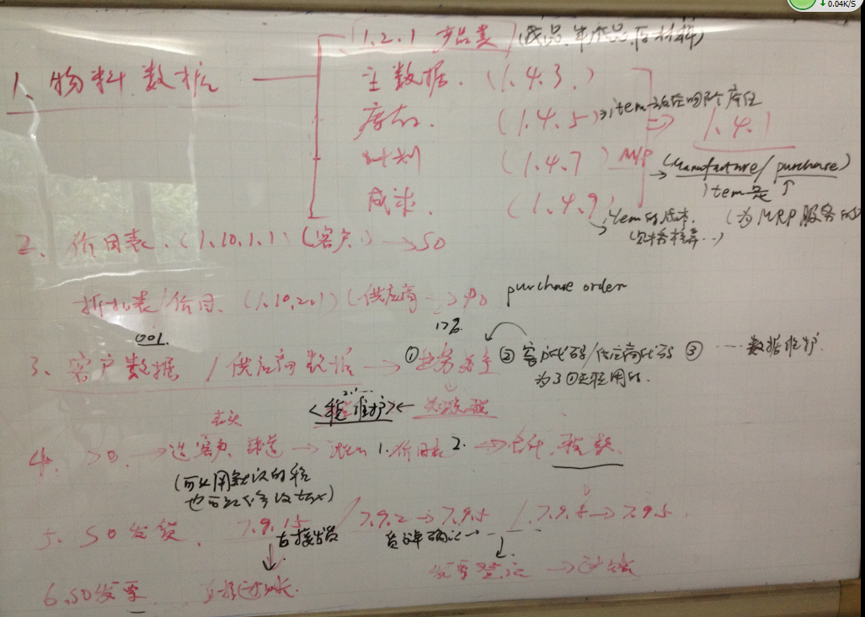

### Foundation data

#### 1.Item maintenance

1)Product Line Maintenance(1.2.1)

Item belong to product line. Product line type as below rectangle highlight in yellow.

Purchased-ext supplier 采购件=原材料

Mfg sub assembiles (Mfg=manufacture)半成品

Finished Goods 成品

*(BI Tip:*

*Track sales, costs, and inventory accounts in the General Ledger (GL) by product line)*

2) Item Inventory Data Maintenance (1.4.5)

mostly check current location for the item

Key field:

* Site

*(BI Tip:*

*Inventory Control is maintained by site.*

*Each site is associated with a specific GL(general ledger) entity, letting you maintain and monitor complete financial results by site or groups of site.)*

* Location

It’s indicating the physical location which the item is stored.

Location often vary by site.

**Lot/Serial Control???**

3)Item planning (1.4.7)

Set up current item as M (Manufactured)

M(Manufacture)/P(Purchase).This is for MRP usage.

Purchase/Manufacture

4)Item cost (1.4.9)

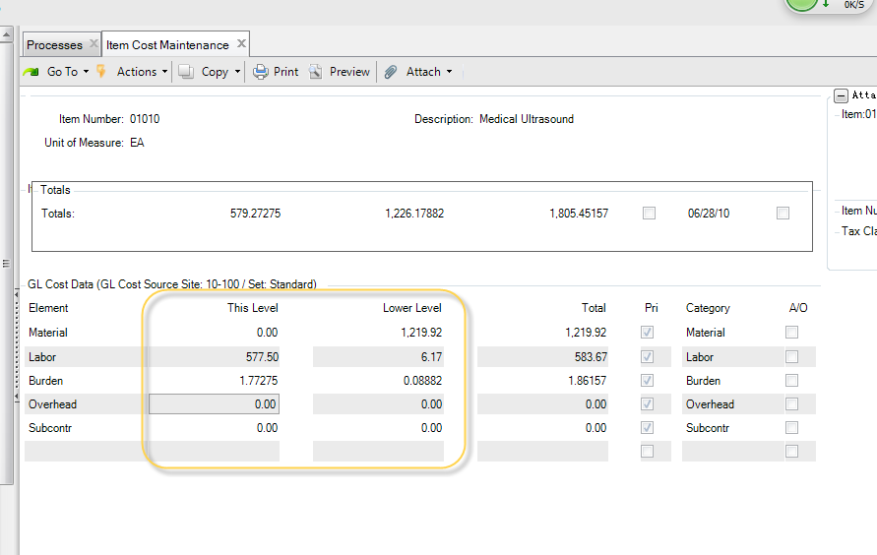

Attention:

1.GL Cost set(Such as the yellow rectangle highlight in above diagram)

As far as purchased item, the cost includes material only in common.

For Manufactured item ,the cost is equivalent to this level(including labor , subcontractetc other cost factor) plus lower level whose BOM items cost.

2.Unit price

1)-4) is summarized of Item master maintenance(1.4.1)

Item data relate to 1.4.3

(Important)Other useful feature:

1. menu 1.4.1 item master

check separate item consolidate information

1. menu 2.1.4 customer data report

browse customer complete information

3.menu 1.6 Item Browse

Browse item complete information ,particularly useful when you need to

Search item by site or other specific column.

#### 2.Price List Maintenance1.10.1.1

1) Customer Data Maintenance (2.1.1)

The site option identifying the site from which orders for this customer are normally shipped. It should be equivalent to the site of item.

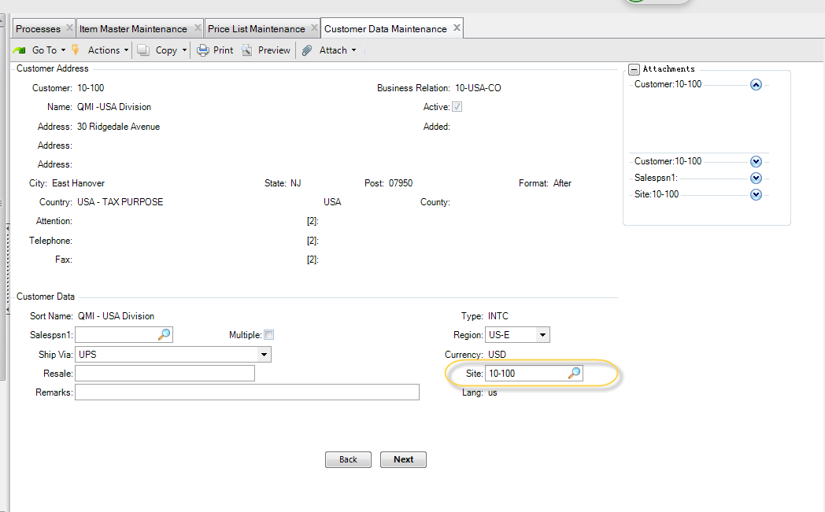

2)Price List 10-100

Start / expired date : the price list effective date

**Amount Type : choose “List Price”**

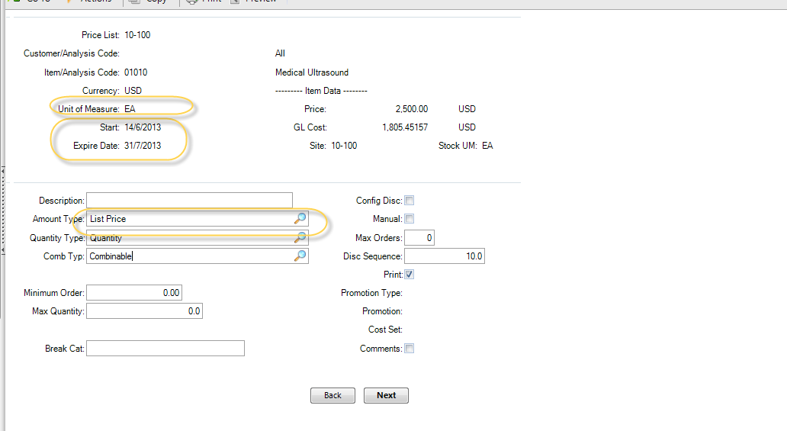

The conflict between List price here and unit price which is maintained in Cost .

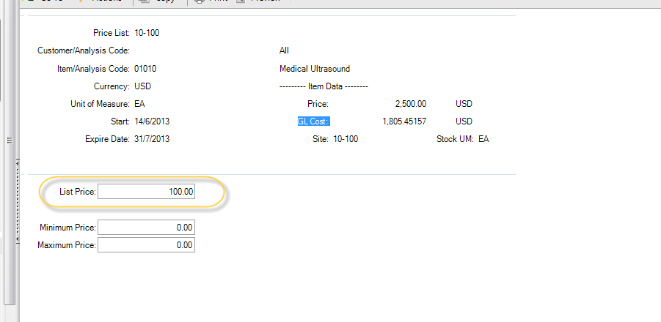

Price list Feature :

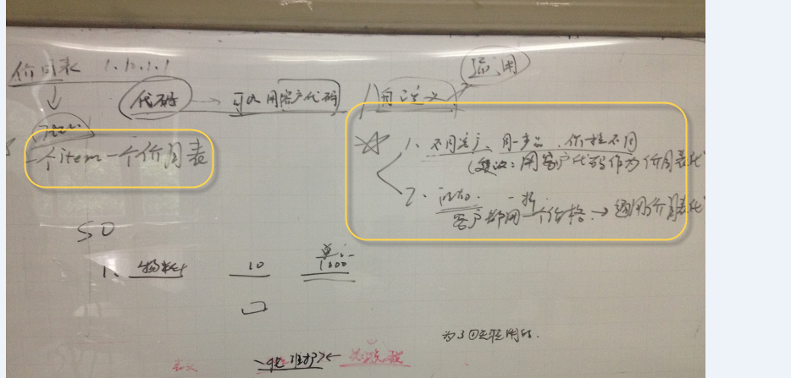

Price Lists by Item Inquiry (1.10.1.6)

Use this page to check current available price list for specific item.

#### 3.Sales Order Maintenance（7.1.1）

Order: the number uniquely identifies a order or pending invoice and it’s line item.

You can type it manually or left it blank in order to generate it automatically by system.

Sold_to: determines the default bill-to and ship-to

Bill_to : Receive the invoice

Ship-to : Receive the item on the order

Order date : the order date

Due date : Enter the date is due to be shipped.

Channel:

SITE : the site originating the sales order or invoice.

(It related to Customer)

Perform date: used for order performance kpi

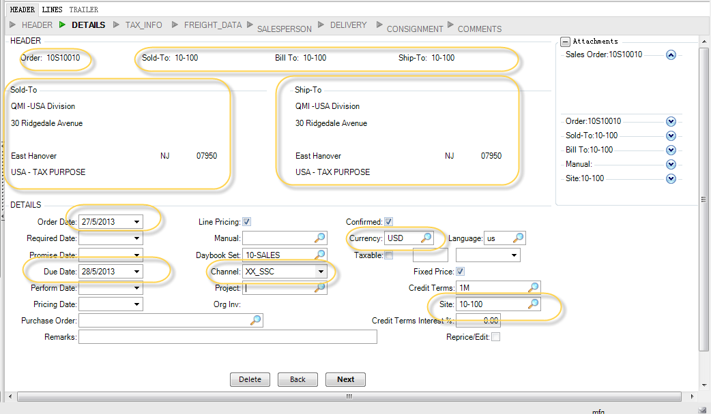

Attention:

When you add a new channel(such like xx_ssc) , the system will automatically maintain the generalized code table to add a new record whose field is so_channel and value is xx_ssc.

*(BI Tip:Here related to the dim_channel where clause as below:*

*Select * from PUB.code_mstrwhere code_fldname = 'so_channel')*

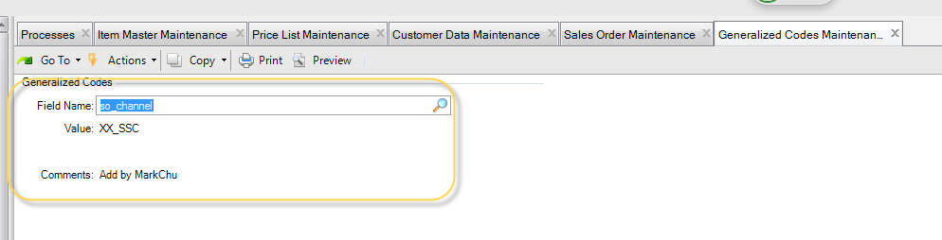

The below pop-up is tax-related information.

Tax usage, along with tax class and tax data, determine which tax rates will apply to the order.

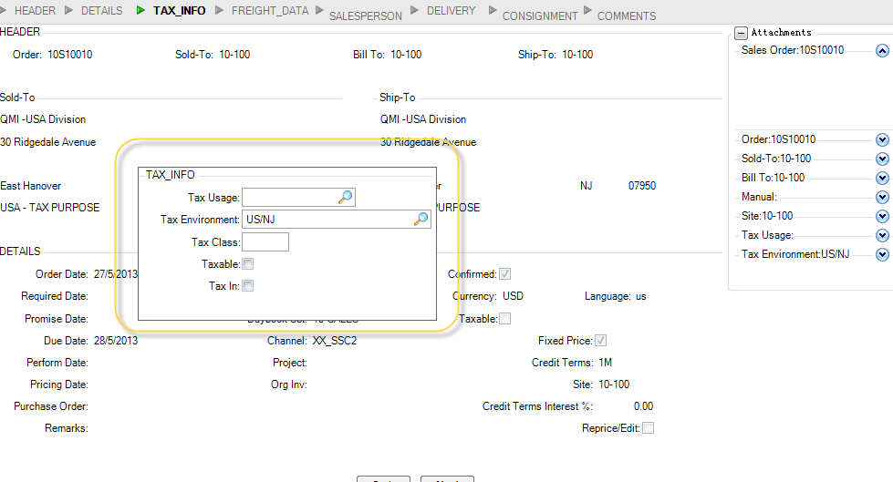

Enter the effective date to use in determining price for this line item.

The system use the default pricing list in the search for applicable price.

If no any applicable price is found, then use the unit price setting in cost center.

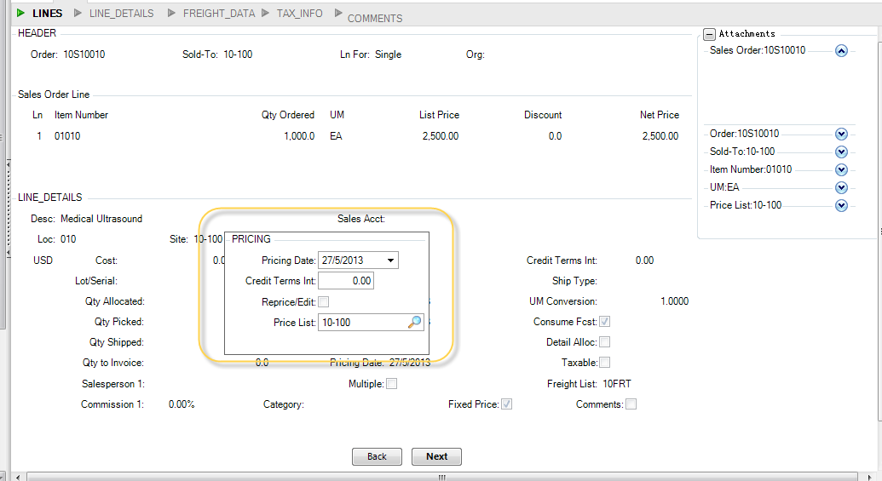

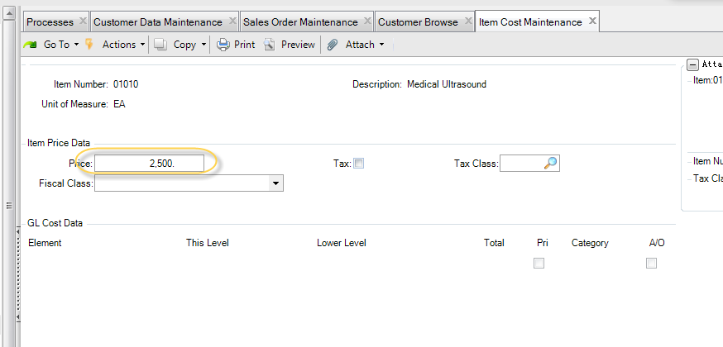

Sales Order Line:

One SO could consist of more than one sales order line

This unique line numbers let you enter multiple lines for the same item, perhaps with

different order quantity or date.

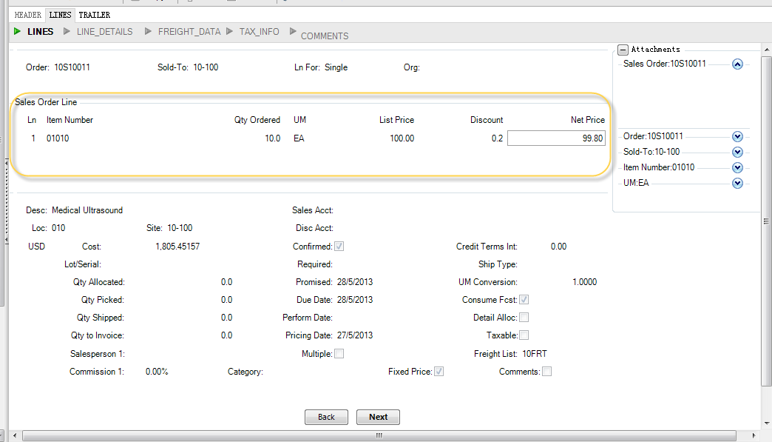

Click “Trailer” button to jump to the result page.

You can review the so result as highlight in yellow as below rectangle:



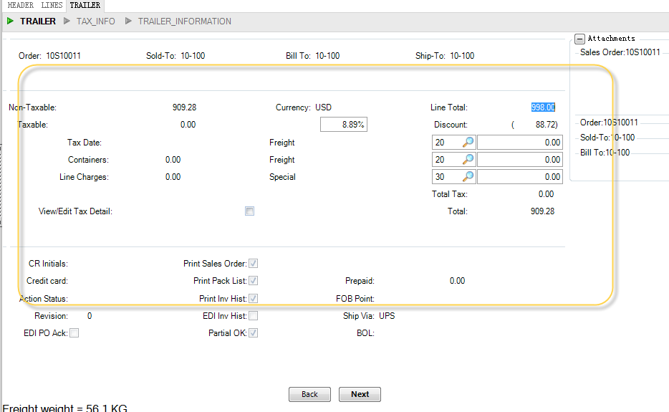

Conclusion:

1.QAD Table influence after generated a SO

so_mstr

sod_mstr

tr_hist

select * from PUB.tr_hist

where tr_hist.tr_nbr=order number

#### 4.Sales Order Shipments(7.9.15)

1) Order

should type the SO ID which is maintained in 7.1.1.

2)Effective Date

The shipment for this period will correspond to your AR and GL balances.

Ensure that specify the same date in effective date and invoice post and print date ,mentioned later.

3)Site

where items to ship is located.

4)Shipment Date

Associated with Order performance KPI

Tr_hist.tr_shipment_date

该ITEM启动了Lot/serial-number（S批序号管理），所有每个ITEM都需要输入序号才能发货。在下面菜单1.4.5将黄色置为空

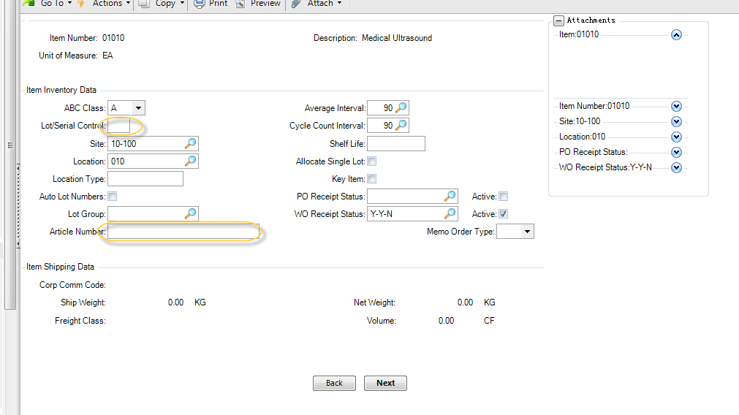

修改完后，在进入3.9

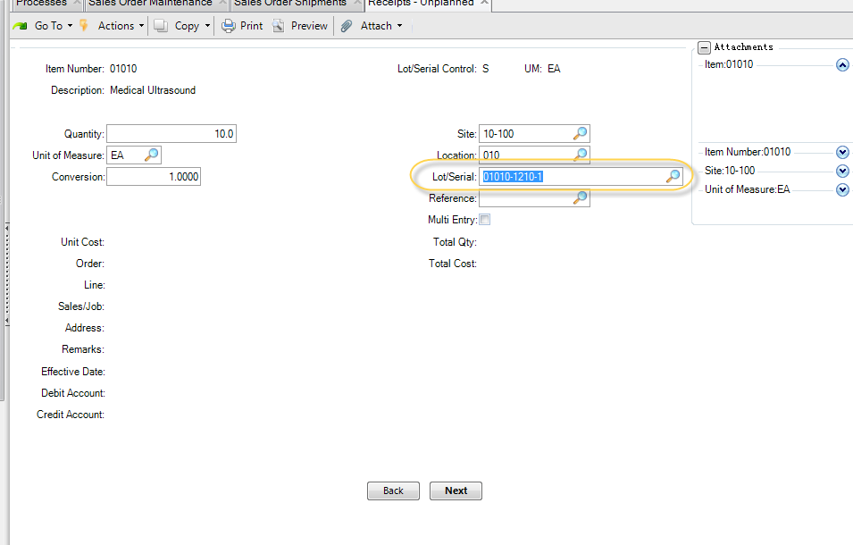

在SO时NEXT会报错，发现该ITEM启动了serial

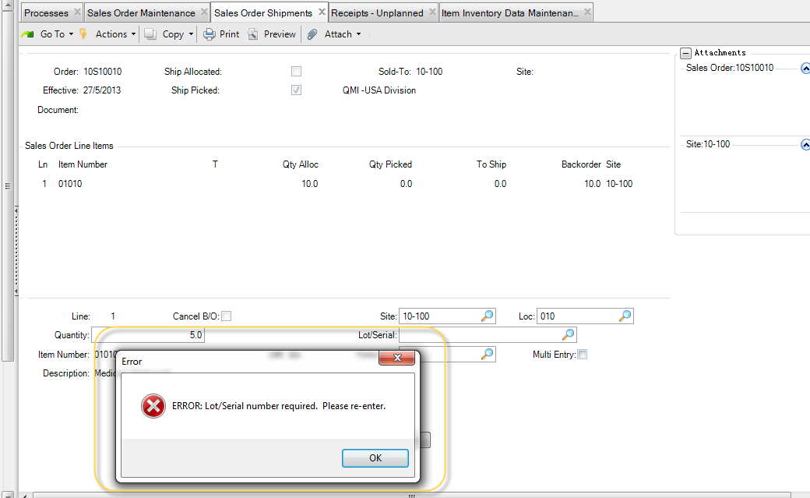

用序号发货：

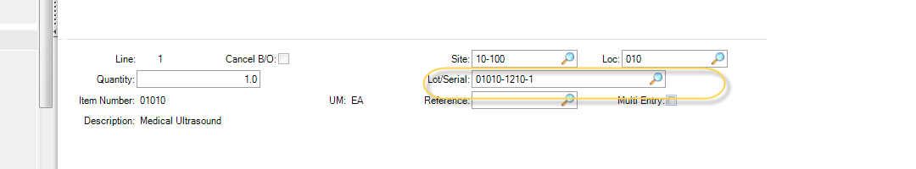

可以选批个发货：

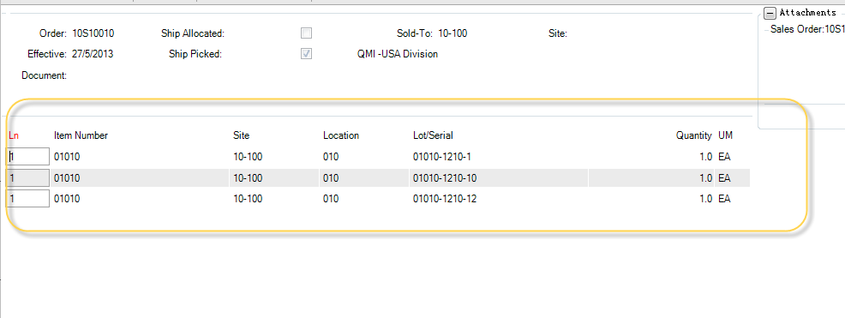

Sales Order Browse(7.1.2) to check the shipment results

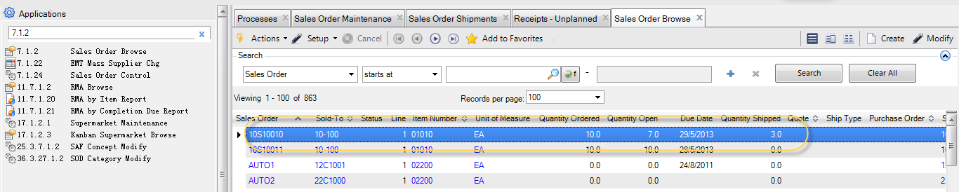

Effective date must be equvilant to order date within SO.

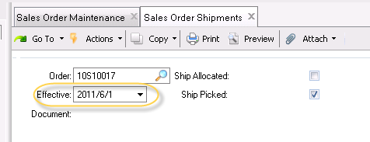

查看是否发货成功:

#### 5. Invoice Posting

After shipment ,we need to act invoice posting in order to gather the amount into AR.

1. Preview invoice print 7.13.3

Preview the invoice amount and quantity

1. Invoice Post and print 7.13.4

GL Effective data : correspond to invoice posting date / effective date

(DInvoice.invoicePostingDate)

Note that:

The below option should be activated in order to modify invoice date

This step prior to set invoice date.

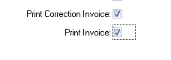

Invoice date :

Note that this option could be activated only when previous step finished.

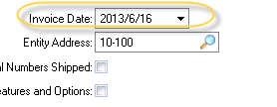

1. Check Invoice posting result

* Relevant menu as below:

Invoice History Browse 7.13.7

Customer invoice view 27.1.1.3

* Database-related information:

DInvoice (correspond to ar_mstr against SE version)

Ih_hist

Posting Invoice

After Posting , the record existing in SO_MSTR,SOD_DET will be removed automatically.

Except that the So shipment only ship particular item ,which so shipment is partly.

Sales Order Tracking Inquiry 7.13.10

2) Invoice result checking

QAD界面上的INVOICE ID

2011/CINV000000223

对应后台DB的字段如下：

** Field Name: DInvoiceDIText

Description: CIDescription. A brief description for the SI posting.

1. Other points

1.Pending invoice register 7.13.2

If preview invoice failed such like a blank page appear, then we use 7.13.1 to register this pending invoice.

2.Pending Invoice Maintenance 7.13.1

This used for modification u need prior to the formal invoice posting operation.

Business scenario is that you can modify the invoice quantity or amount .etc.

Note that:

Alternatively unfortunately the modification is forbidden if the invoice had been registered in 7.13.1 .

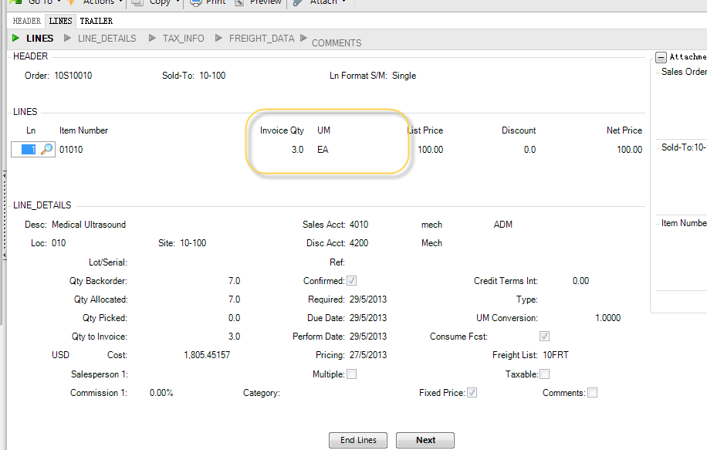

INVOICE的总金额如下黄色框：

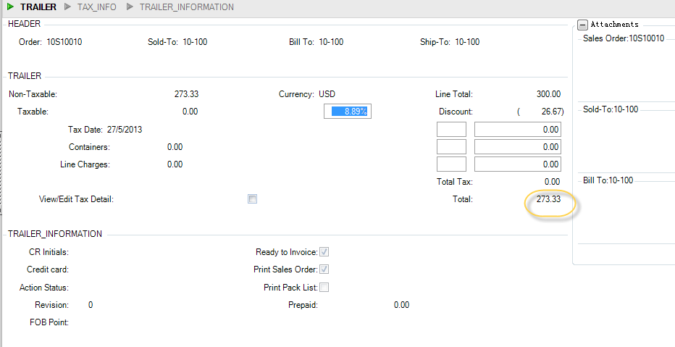

5. Purchase Order Receipts（采购收货）

Glossary:

1.毛利润

总金额-成本（所有支出成本）

2.净利润

毛利润-税额

#### X1.Set up printer

注意：报表需要先定义打印机。36.13.2

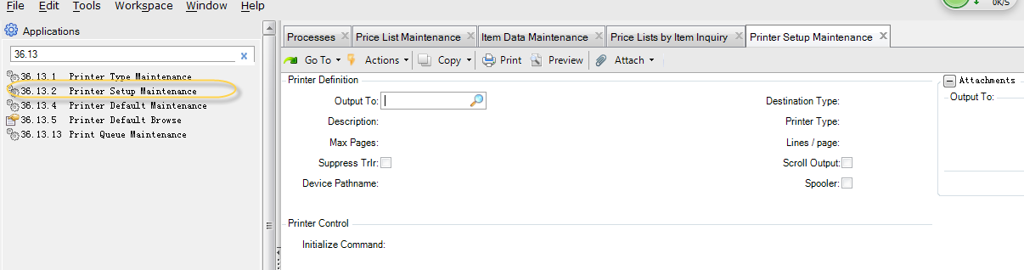

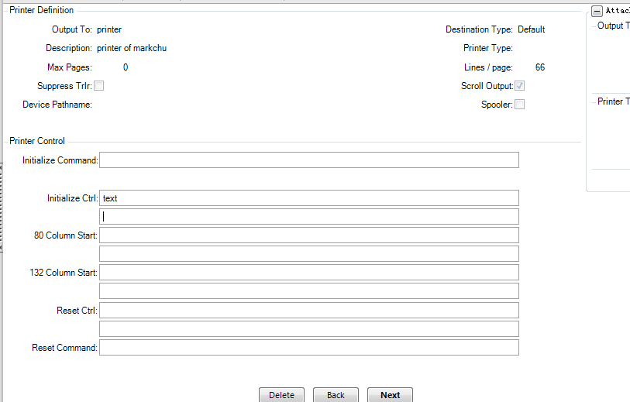

#### X2.Modify GL Period & Domain Period

1)Use this feature to unlock and open the closing GL period

25.4.2.4, BPeriod. UndoLocked

2) Entity GL Period Modify 25.4.2.1

3)Domain Period Modify

25.4.1.1

#### 6.SalesPerson

Maintain data associated with Dim_sales_person

### TroubleShooting&To-question

1.Lot/Serial of item inventory data Maint?

是批量/序号管理吗？BarCode成品入库方式？

2.系统有限选的是ITEM COST的PRICE，然后才是PRICE_LIST 页面的价格?

3.Why there are two record in TR_HIST table as following diagram:

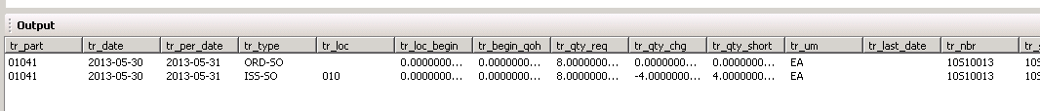

TR_TYPE describe below:

ISS-SO：客户订单货物发运

ORD-SO：客户订单帐目

Answer:1.做SO 会有一个事物 ORD-SO

2.发货有一个事物 ISS-SO

7.13.4

Posting invoice failed :

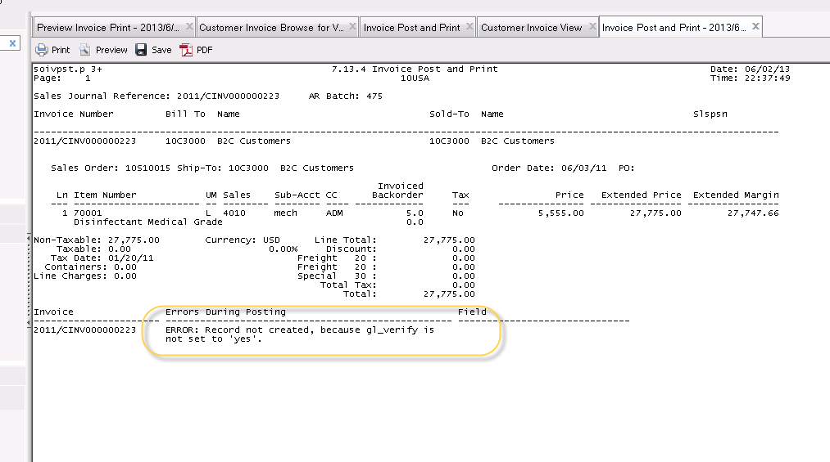

36.9.24 domain/account control

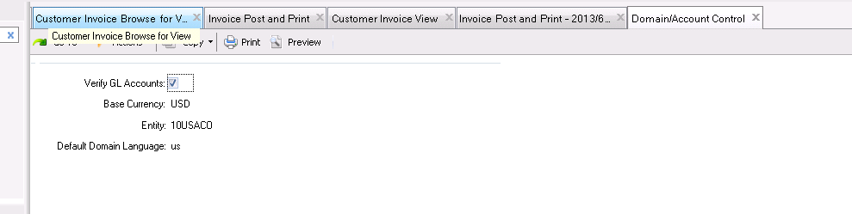

7.How to attempt to eliminate the restriction for creating a old date so?

25.4.2.1 open corresponding month period then save



## PO purchase order

1)5.7

## District ion Manufacturing Module

1.4.7

only containing P/M properties can use MRP

QUESTION1:工单下达后，能审批吗？

QUESTION2: 销售订单转换成工单

SO transit to WO

Q3:费用工单的用途?

没有料号的可以在这里开工单?

WO料号不存在，不给下达?

1.在试产过程中应用，因为BOM不固定等其他因素

2.费用的跟踪

现在就要做未来3年的某ITEM WO计划。

Terminology explanation重复生产？

例如汽车生产….,生产周期很短、工序也很简单。

23.10

物料清单 配料？是展示BOM最高成品 OR BOM的整个结构

## AR Account Receivable Module

Agend:

1. AR foundational setup
2. Customer data
3. Sales flow & AR
4. Customer payment

Whats’ daemon?

AR Daybook set ?

AR/AP 日记账

不同的类型给不同的序号

(a unique different serial number associated with different type)

例如 库存、销售。。。

Customer paying status

客户付款状态 27.6.2.1 (menu id)

托收（委托XX收款）

Designate someone as consign to receive the debt.

**客户维护步骤**

27.20.4.1=>36.1.4.3.1=>27.20.1.1=>2.1.1

业务关系创建

国家代码 不对,税务信息就不对了

The incorrect County code will cause tax information error.

一个客户对应一个业务关系

One single customer correspond to one business relationship

Extension points:

1. 客户能做什么？不能做什么？

Pre-payment 预付款

Profile 取科目

发票的状态

For instance, SO had ship

# Financial Summary

When / what / where / how

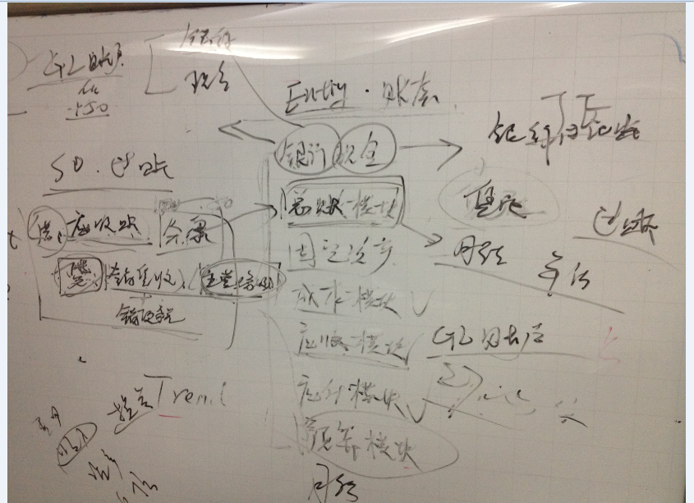

## PART2 工程技术

**QAD事务类型对照表**

Inventory Status Code Maint ->

Position on Restricted transaction and

Press F1 key to populate the help page.

We can view the Transaction type in this page.

CST-ADJ：成本调整

CUM-RADJ：累计收货调整

CUM-RRES：累计收货重置

CUM-SADJ：累计发货调整

CUM-SRES：累计发货重置

CYC-CNT：周期盘点调整

CYC-ERR：周期数错误

CYC-RCNT：周期重盘

ISS-CHL/RCT-CHL：改变库存细节

ISS-DO/RCT-GIT：分销订单发货

ISS-GIT/RCT-DO：分销订单收货

ISS-FAS/RCT-FAS：最终装配单

ISS-PRV：采购退回供应商

ISS-RV：库存退回供应商

ISS-SO：客户订单货物发运

ISS-TR/RCT-TR：库存转移

ISS-UNP/RCT-UNP：非计划发放/收到

ISS-WO/RCT-WO：加工单发放/收到

ORD-PO：采购单帐目

ORD-SO：客户订单帐目

ORD-SEO：材料单帐目

RCT-PO：采购单收货

RCT-RS：库存退货

RCT-SOR：库存客户订单退回

RJCT-WO：加工单拒绝

TAG-CNT：实际库存更新

WIP-ADJ：在制品调整

WO-CLOSE：加工单结算

ADD-PO：加到采购单

ADD-SO：加到销售单

ADD-WO：加到加工单

Generalized Codes Maintenance

Maintain Item transaction Type:

1） EXCEL transfer to text format then upload to VM

2）36.15.1 CIM Data Load type the location of the uploaded text

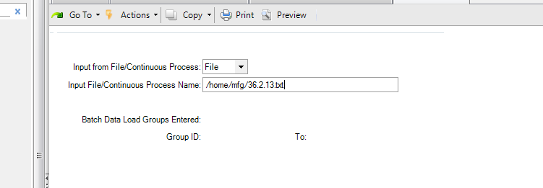

Remember the Group id highlighted in yellow

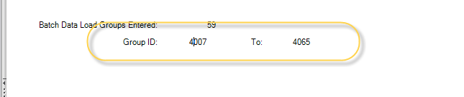

3) 36.15.2 CIM Data Load Processor

Type the groupIdinterval

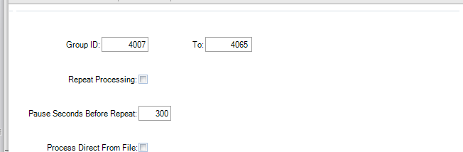

4) check the result in menu Generalized[ˈdʒen(ə)rəˌlaɪz] code Maintenance.

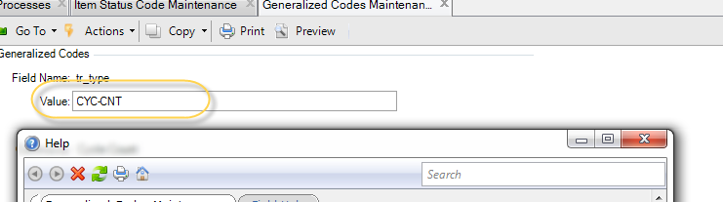

5）库存状态代码维护1.1.1 Inventory Status Code Maint

C:\Users\markzhu\Desktop\MarkDesktopFile\Library\QAD EE\2008SE\2008SE\

2008SE-仓库模块.PPT

5.1.需要新增库存限制事物

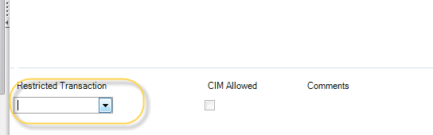

6）地点维护(Site Maintenance)

YYN 是库存事务类型N表示不可能过量发货。

Automatic location 不钩，表示不自动分配仓库库位。

黄色表示重要栏位。

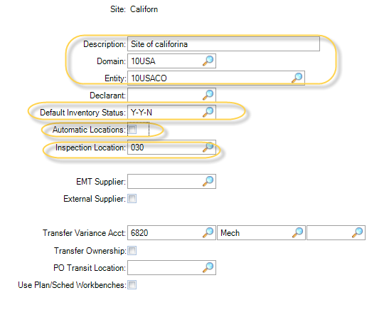

7）库位维护1.1.18

地点的概念(Refer to My iphone photo)

Site choose the new site created on previous step.

Generate a new Location .

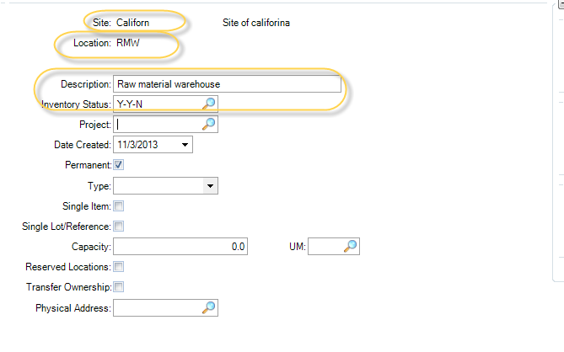

8) 付款条件维护

Credit terms create36.1.10.1

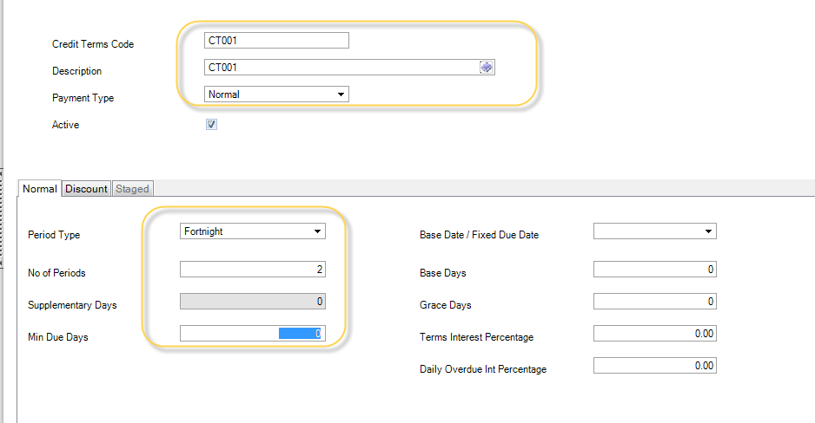

折扣页签可以选择在一定时间内提早还款，可以给多少折扣。

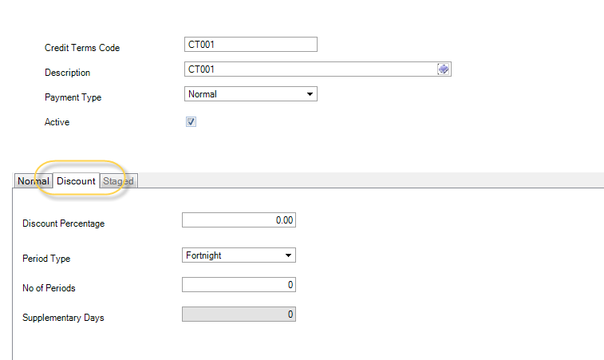

ERROR :

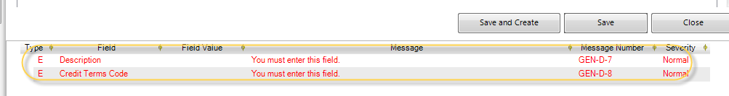

9）供应商维护

S1、业务关系创建（其实就是地址信息）

1）成品发给最终用户

2）供应商应该把采购的原材料送到哪里

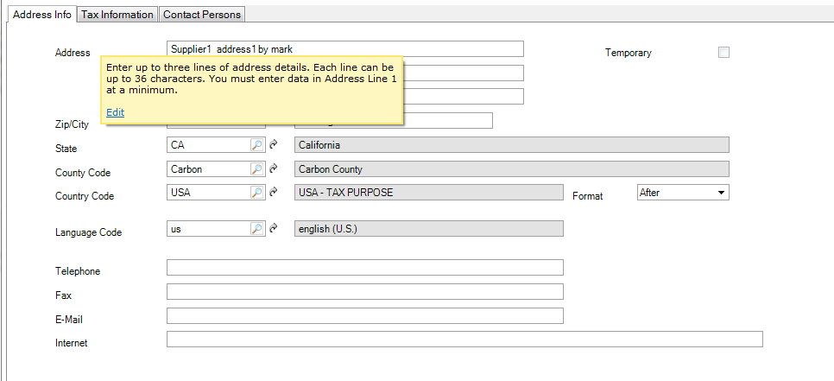

First option means tax is mandatory .

Second is means whether including tax expense.

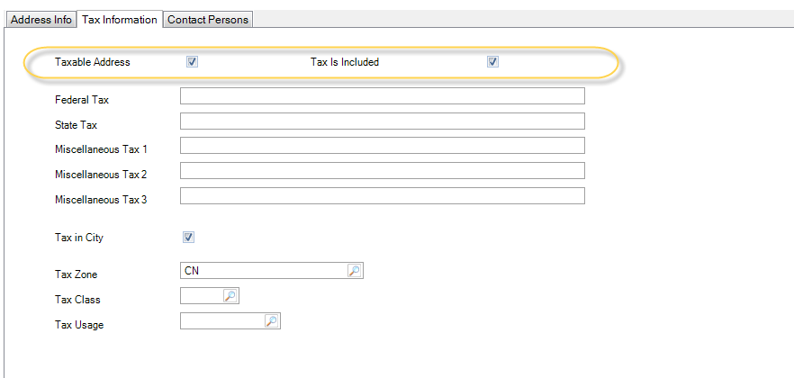

S2、供应商

Business Relation choose previous BS .

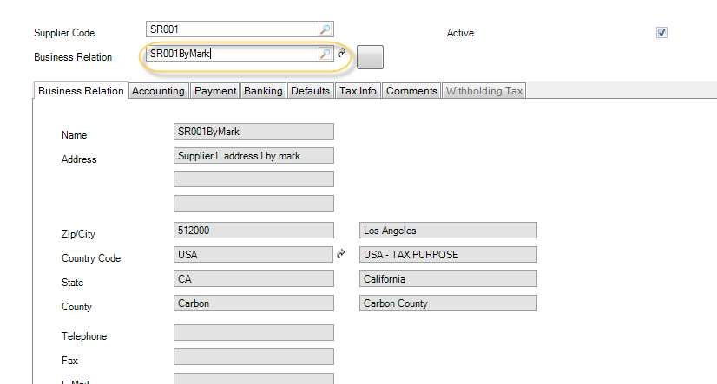

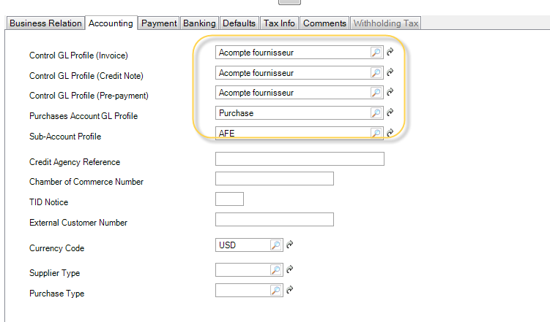

Payment :

1.Credit terms using former generated

2.Invoice status code (mandatory is RM-INIT)

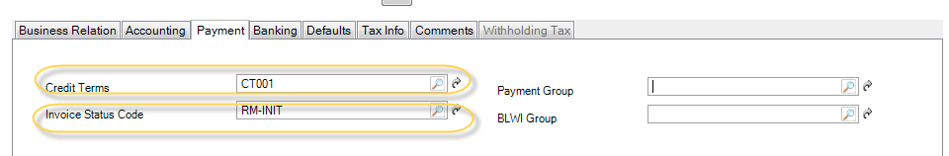

银行维护需要另外维护，但这里先选系统默认的。

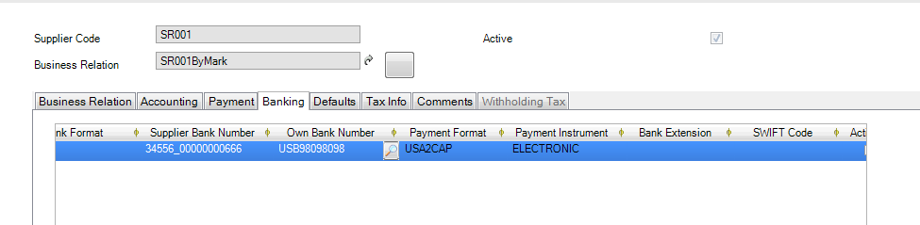

TAX-INFO is populated from BS maintenance .

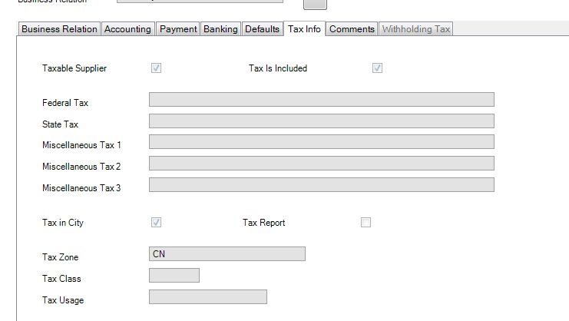

S3)供应商数据维护2.3.1Supplier Data Maintenance

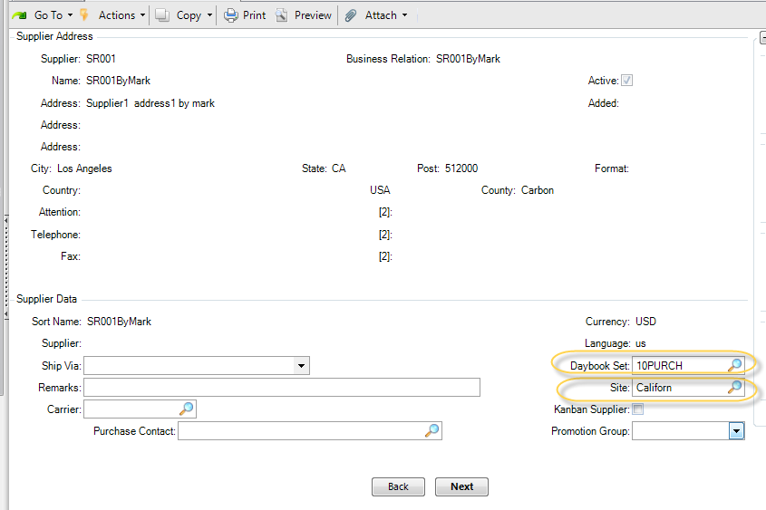

S4）使用2.3.2查看供应商

### TroubleShooting&Puzzle

1.plan is the meaning of 排程？

## June8.2013 Sam

1.Lanuch [lɔntʃ] VM

Type this command ./callmenu to list all available options



Choose 1 option to startup QAD including background database



2.启动WINDOWS QAD UI工具

3.修改用户属性

（36.3.1 用户维护）

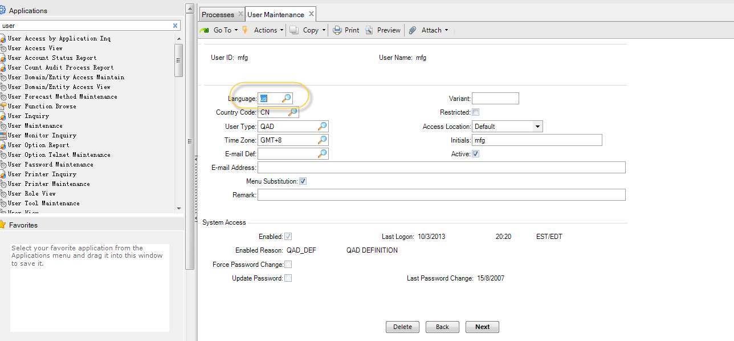

EXCEL0

Excel Sequence11

Error1: import the file modified manually just former exported

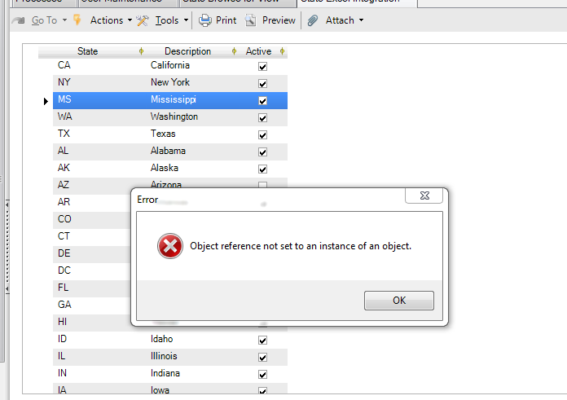

36.1.3.2 State browse fro View

Inquiry for state

### Excel12

All the function is use VAT

所有用途都用VAT

1.什么是VAT?

从中国发出到任何地方的货都是用VAT的税

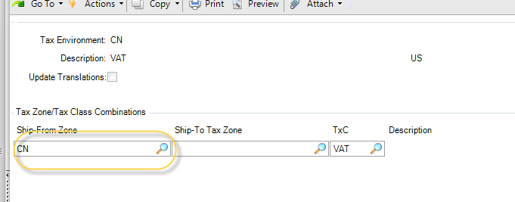

发票的状态invoice active status

SI

CI

从AR上来说(account receivable)的状态会设置成简单点.

AP（先收到供应商，后财务做帐，还要匹配、审批）的状态会比较多。

AP两类：

1. MEMO(3种状态INIT OK2PY NOPAY)
2. PO=>REC(receipt?)=>AP（3单匹配）

QAD preferred-operation type :

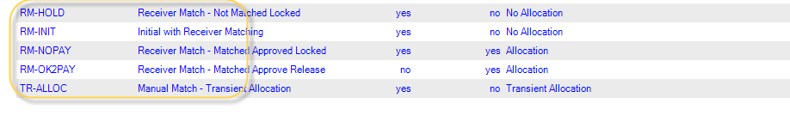

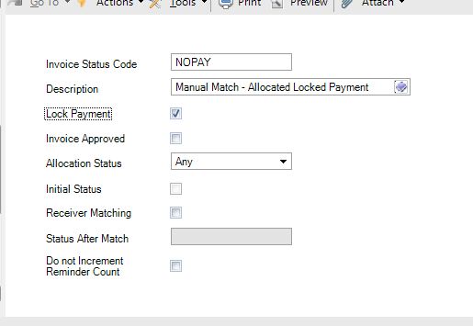

没有采购收货的INIT状体：

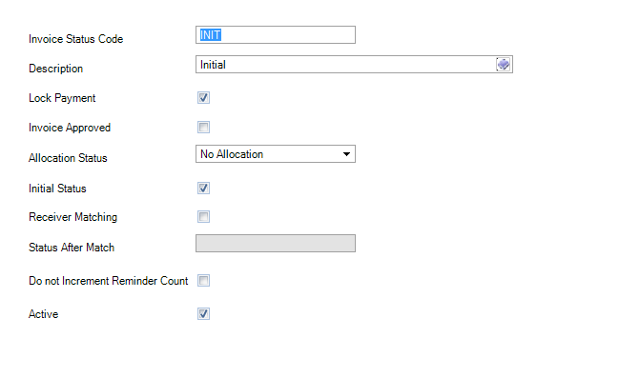

NOPAY：

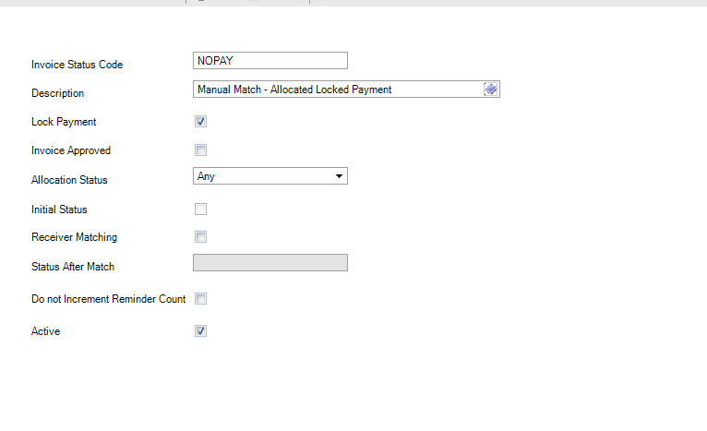

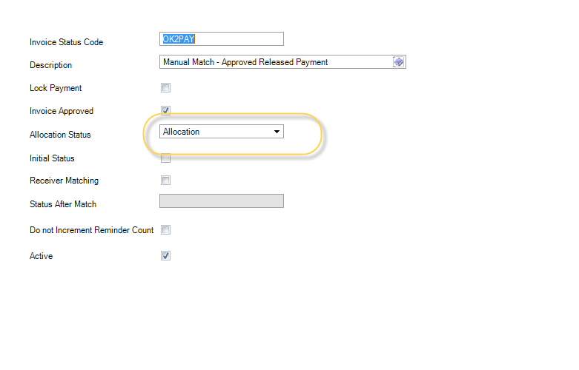

Receiver matching :表示已经3单匹配了。

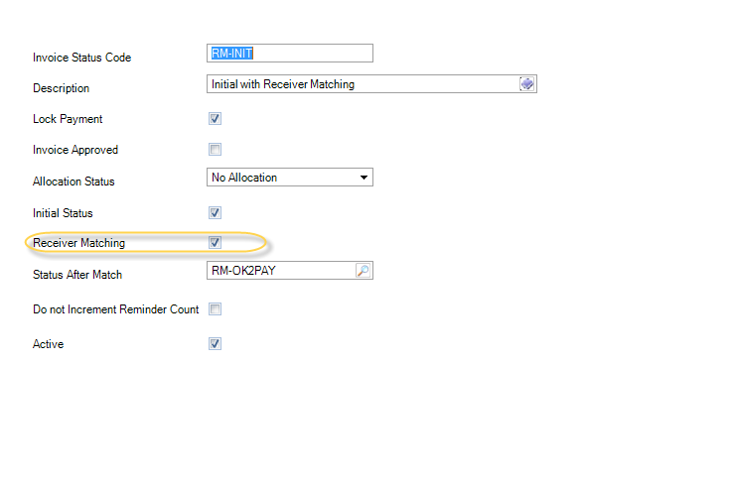

3单匹配可以转到临时层：

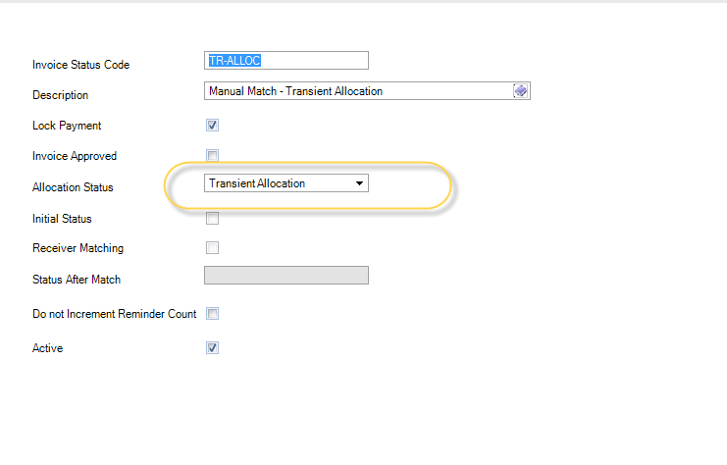

14

发票日期所在月的月末的下一个月

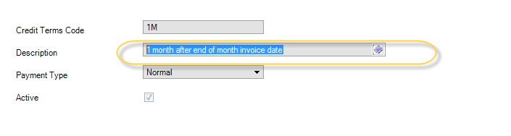

30天到期日，但如果10天付款，给2%的折扣

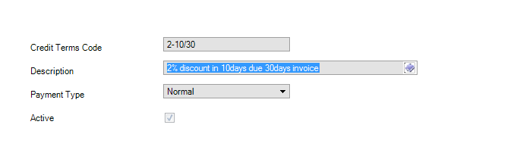

EXCEL15

EXCEL16

SAF

1.WO发料

1）从财务科目的角度来说，库存100W是一个汇总数目。财务不能做分析。

从TR_HIST来看，可能是：

五金（不同的产品线PRODUCTION LINE）

用SAF，ITEM更加具体。从财务角度可以将汇总数目看到明细。

将ITEM的具体数据带到财务的汇总数据看。

2）如果产生差异，还可以看到差异。

SAF对产品更加细化的分类。

SAF

1.子模块=》GL

2.总帐分析

备用、成本中心

## Common Functionality

1.Item物料

End product成品、半成品

Pt_mstr

2.Purchase

1.PO (Menu_id5.7) Purchase Order PO采购订单

Po_mstr (master table of PO)

采购单单号PO_NBRpk(一张单的单头，整个唯一)

供应商po_vendor、采购员po_buyer、货币currency、备注REMARK

Pod_det(detail table of PO)

POD_NBR pk (FK related to po_mstr)

PoD_line项次 PK

Site 地点

**零件ITEM**

**QTY_ORDER数量**

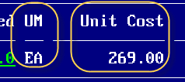

Operation:如何打开PO？

通过F1将光标移动到栏位上，按Ctrl+F查看对应数据库字段

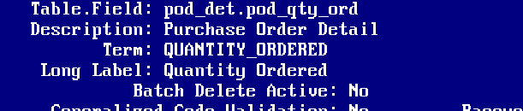

2.4）通过报表来分析哪些字段比较重要？

MENU_ID 5.10 / F2选择。

报表的参数都是MSTR表的信息。

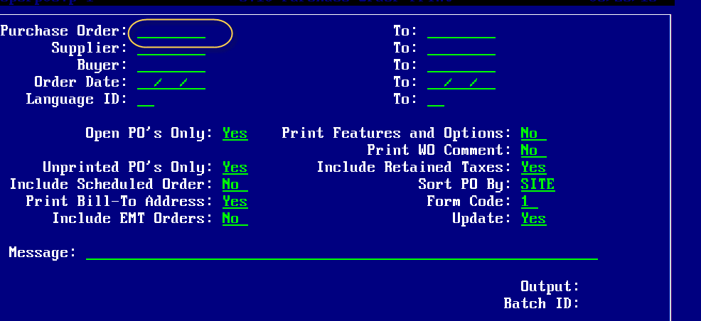

3.SO 销售(7.1.1)销售订单

1)So_mstr

So_nbr订单号

Order_date订货日期

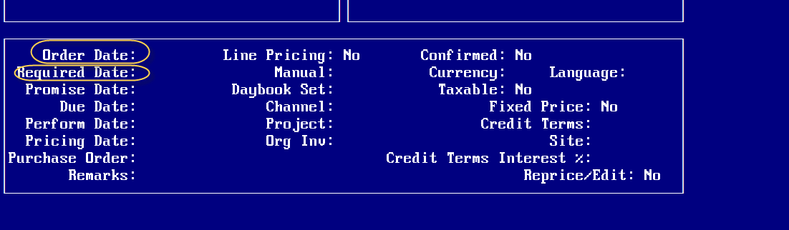

红色部分来源于so_mstr

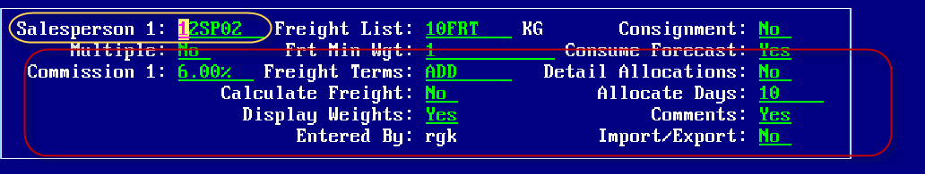

so明细表(sod_det)

Net Price净价

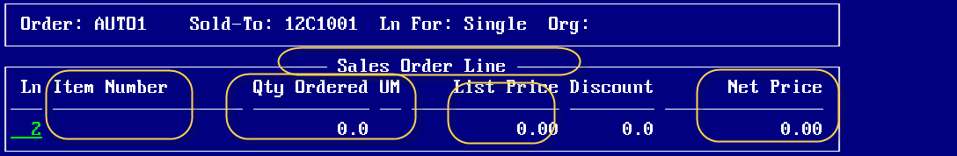

3.tr_hist查看基本上交易对库存都有影响

好像采购收货退货、销售收货退货、工单发料。。。。，发生事物

tr_hist库存交易记录(查看库存数量)

只要产生一笔和库存有关，涉及到库存变化的都会记录到这里

（出入库、转仓、发货）

tr_date发生库存的日期

tr_loc =>loc(location库位)

tr_lot(**批次管理**的批序号)

tr_part(物料、零件)通过零件号和SO的item

tr_site

tr_nbr(SO、PO的单号)

3.21.1 事物明细查询

3.6.5(库存明细查询)

业务人员一般黄色标识的内容查询库存信息。

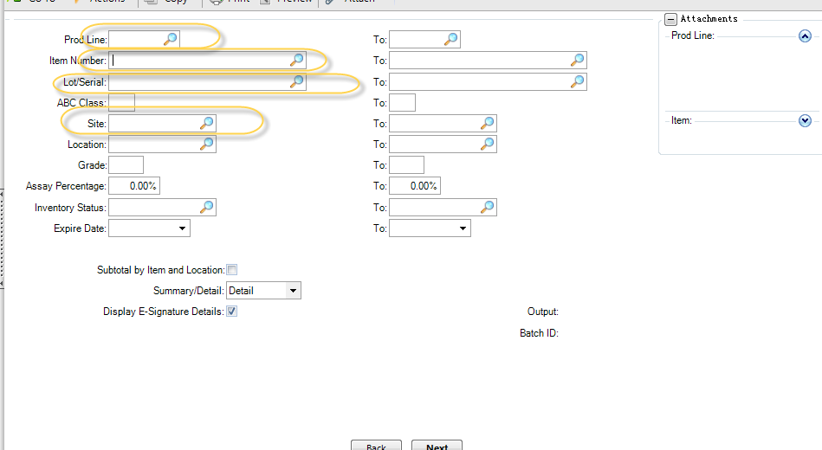

另外还有一个库存交易。

作业：

1. 先做一张采购PO
2. 要收货5.13.1，查看3.21.1 事务TR_HIST
3. 做一个退货采购退货 5.13.7，TR_HIST

4.库存相关表ld_det(Location detail)

Menu_id3.6.5查看

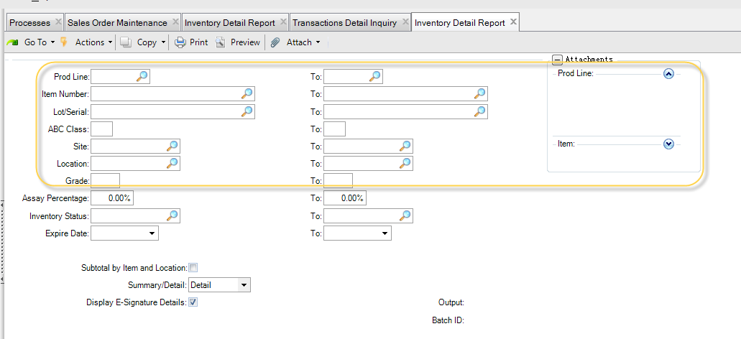

库存通常不能手工维护。

5.零件主文件维护（1.4.1）

pt_mstr Item Master

查用字段：

pt_part char im

20 pt_desc1 char i

30 pt_desc2 char i

40 pt_um char

status 状态标识是否可用

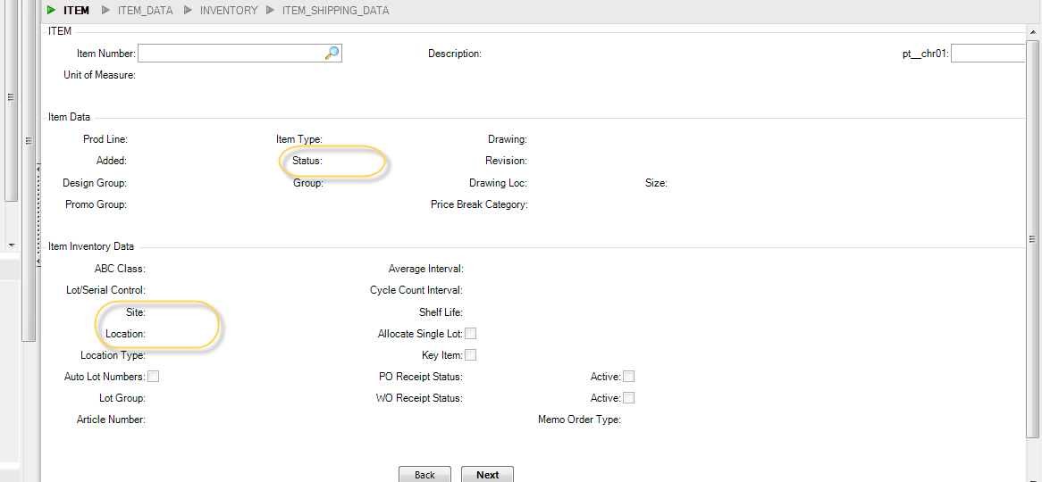

1.4.3 / 1.4.5 / 1.4.7 / 1.4.9 合并在一起成1.4.1



4.工单16.1

生产一个东西，需要做一个东西。主要用来计算成本。

下一个

wo_mstr工单主表

工单号

wod_nbr char

wod_det工单明细

5.财务

应收、应付(ERP最后一步)

ar_mstr Accounts Receivable Master

ard_det Accounts Receivable Detail

Ap_mstr()

6.Invoice

客户收到INVOICE，要对账。

这个有价钱。由财务出的。

AR里面产生了一批科目。

从发货开始到INVOICE。。。。

CFO CONCERN:

1. 出了货，INVOICE还没有
2. INVOICE出来,AR还没收到款

QAD training file location:

E:\Softspeed BI Team\MarkChu\AllJobStuffs

\F Hardisk Job\Jobs\Softspeed\Document（文档）\Industrial Solution（行业解决方案文档）\QAD ERP\QAD2010EE版

QAD information

Six industrial

1.automotive 汽车

2.electrionics 电子化

BOM 最简单(most simple)

3.food and beverage

4.Life sciense

5.麦瑞 physical

10% manifaturing industrial.

委托库存 designate inventory

Why choose QAD as our erp vendor?

1. Rich expienrcedelectrionics丰富的电子制造业经验
2. Low risk 低风险
3. Fast take effect快速见效
4. Greate competitive overall Own cost具有竞争力的总体拥有成本
5. High-rate ROI return on investment 高投资回报率

152Remote EE Demo environment startup profile:

QAD VMW startup

1)Locate the file cd/home/mfg/startall.sh and run it to startup QAD service

Tips: QAD account is mfg/mfg

1. use QAD Windows client utility to sign in QAD

1.QAD system 基于数据库共享

DOMAIN是基于数据库划分的独立范围，彼此是独立的。

(divide database data into different ,complete independent )

DOMAIN间通过Shared Set Data共享数据。

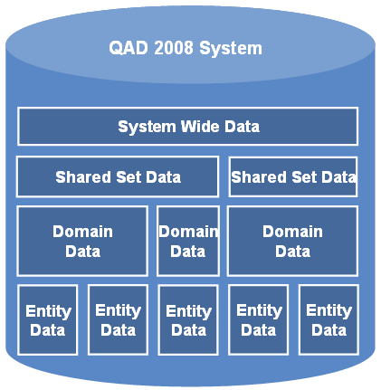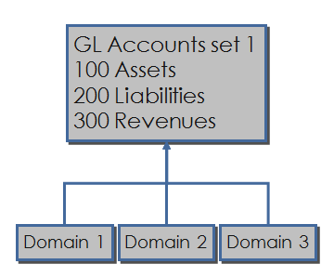

1. 业务关系 Business Relationship

2.Profile个人主题(具有相同的业务流程、科目计算)

制定客户用某个profile

Specify certain profile to customer .

This kind of cusmter has same business module .

Demo1:

1. establish domain
2. create business relationship

qad menu id is36.1

1. create data

s1.based on Domain -> Role authorized Maintenance角色许可维护

财务合并报表( Merge Report)

不同的ENTITY （大陆和美国）的计帐方式不一样的。

每个帐目只能过到一个层面。

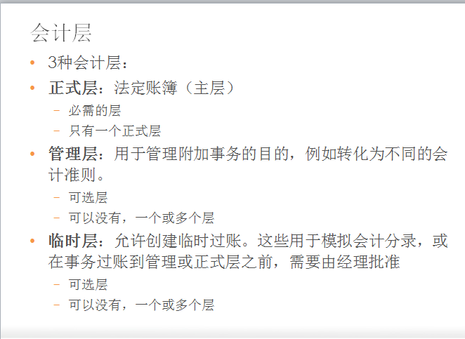

Daybook 日记帐、流水帐

Financial account infrastrure:

Debit : Account -> sub-account->cost center->project->SAFs

??掩码mask-code

QAD sign in/login on Domain level rather than database layer.

QAD登录的是DOMAIN级别而不是数据库级别。

EUR 兑换 CNY/USD

European exchange Chinese/Us dollar

QAD EE(enterprise edition) on demand

Module is Purchase

Huge changeness from EE above version

1. supplier maintence
2. generate prefix

1.Supplier maintenance process

**Step1: maintain business relationship**

Tip:Business relationship could based on database or domain

Contact is restrict to be not null.

Planet group maintenance

Supplier code couldn’t be equvilant to Customer code within

the same relationship

Restriction options :

Domain restriction is used to limit the access switch between different pages.

**Step2: Supplier generation maintenance**

Tip

Take effect option

**Step3: Supplier data ganularitymaintence**

**STEP4: Supplier 物料 maintenance**

**Step5 : purchase order maintenace**

English Version for Powerpoint

应收和应付自动冲平

封锁事物 Block Transacation

物料

Receipt / invoice

订单接受成本

货运单/集装箱

EMT？

收货单报表

Logistic 后勤

Ledger

可数名词

总账；账簿；账本 A **ledger** is a book in which a company or organization writes down the amounts of money it spends and receives.

General ledger

Operation 经营

1. Transaction between different tax rate need to exchange?

QAD分销制造生产模块

物料需求计划模块

Material Resources requirements planning module

BOM ?

MRP需要解决的问题：

（WHEN WHAT QUANTITY这个MRP告诉我们XX的方法）

只要在BOM的BOTTOM就是采购件。

BOM非LEAF就是需要由其他物件生产出来的。

Glossary termination:

1. Independence requirement独立需求

2. Order Release

3. inventory status code maint

Relative Requirement 相关需求

从一个材料购买，需要购买其他的材料

Article Key

Artificial item

虚拟件的用途 functionality of articial

安全库存的作用 Safety inventory(stock?)

MRP horizon (120) 描述最长的采购时间。累加提前期

Order Release Horizon

1.3.x产品结构维护

Product structure maintenance

根据产品的BOM结构,推算出物料计划下订单的下达日期

1.4.7 物料计划数据维护

Material sources planning data maintenance

直接销售产品是主生产计划。

非成品就是非主生产计划

1）主订单 MPS

2）计划订单 PS

什么状态下，“需要MRP” 自动打勾option will be checked automatically by system.

LFL lot for lot 分批订货方法

POQ Period of Quantity 周期订货方法

做一个日期的例子

1 -> 15

举个实例来介绍 Training Case

FOQ Fix of Quantity 固定订货方法

LFL 是什么?

什么是MPS? 企业得到一个平稳的主生产计划。

这个月收到很大的订单（1W），但下个月可能没单。

就把材料进到库存里面，但先不生产。

什么是排程？

安全库存是什么？

Sales/forecast 销售计划/预测

根据MRP来分析，两个方面一个是产品结构、物料库存信息。

系统核心。

用客户具体的业务故事来分解这个核心图表。

MRP计算方法

1. MRP Basic foundation Module
2. MRP planning parameter setting

1.Accesst Balance Sheet 资产负债表时刻点(Time point)

借库存、贷采购收货

1)东西收到了，还没有开票未确认AP

贷方(CREDIT)

2.P/L 区间 (period)

所有收入（贷方）-所有支出（）

所有成本、费用都是借方（DEBIT）

销售、销售折扣贷方（CREDIT）

3.应付款是贷方（C）

科目定义是借方还是贷方？

3和4是一起产生的。

1. （工单结算）吸收科目 WIP科目、人工吸收、制作吸收

5、销售出货

6、月结

不结算利润。在年结的时候计算，一次性将利润结算到历史利润中。

1. Sc \ Bc

Statutory currency法定货币

**1、Return on Capital Employed**

**ROCE ratio**

动用资本回报率的计算方法是，用[息税前利润](http://wiki.mbalib.com/wiki/%E6%81%AF%E7%A8%8E%E5%89%8D%E5%88%A9%E6%B6%A6" \o "息税前利润)([EBIT](http://wiki.mbalib.com/wiki/EBIT))除以总资产和流动负债的差值。

|  |  |  |
| --- | --- | --- |
| ROCE＝ | EBIT |  |
| Total Assets - Current Liabilities |

|  |  |  |
| --- | --- | --- |
| ＝ | Operating Profit+interest |  |
| Equity Shareholders' Funds+longterm borrowing |

## July22.2013

7.1.1 纠正发票

发票回充

1.How to avoid the VM interval gap time ?

修改这个文件/etc/resolv.conf  
增加：dbserver  192.168.0.55

销售订单🡪

发票过账7.13 invoice post and printer

🡪客户发票创建(Tc发票。。只要是纠正，只能填充负数)

🡪纠正发票

（在GL设置4舍5入差异的会计科目，因为是双本币，都存在一个兑换率）

Rounding differences.

# QAD EE Internal Training

## Prerequisites/Setup VM

1.QAD EE VMW location

E:\Softspeed BI Team\MarkChu\VMW\VM-2011.1EE-Demo

2.QAD EE VMW configuration process is included in below doc:

QAD2011.1EE CONFIG.doc

3.Training Power point location as following below:

C:\Users\markzhu\Desktop\MarkDesktopFile\Library\QAD EE

4.Log on QAD EE through Windows client suite tool

5.install Microsoft Silverlight

Run C:\Program Files (x86)\QAD\QAD Enterprise Applications 2011.1 EE\

SVGView.exe manually

## WorkProcess工作流

Sign on the QAD UI then the default page is process main page.

S2:create a sub process

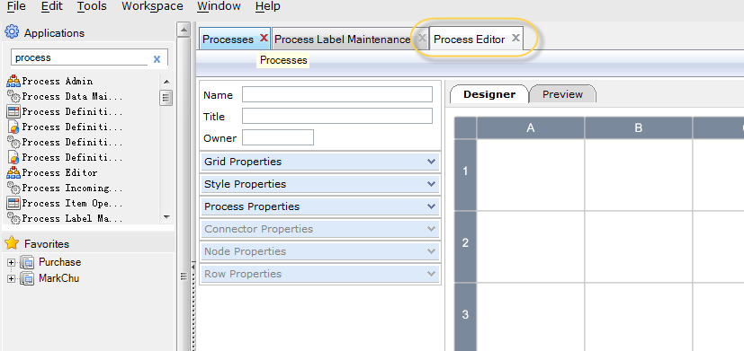

S3.relative parent process to sub process

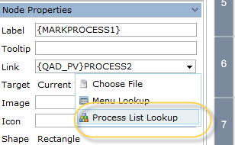

Choose the former sub process in the populated page as below:

Tip:Ctrl+F5 to activate populated searching page.

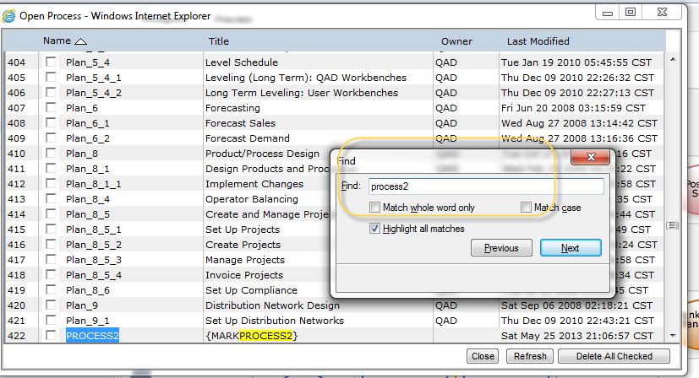

## Menu Permission菜单权限

1.create browser

Menu id (browser maintenance) 36.4.8.13

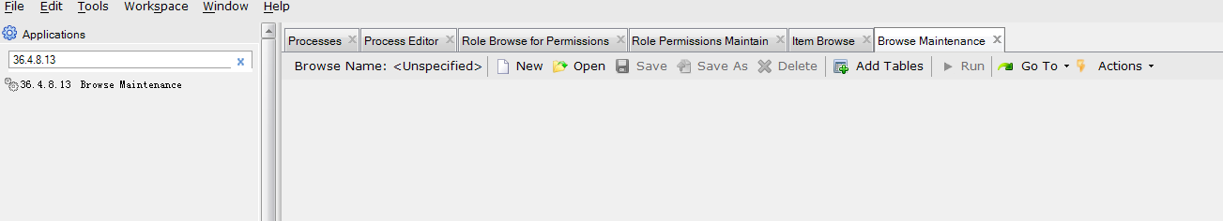

Click “new” to bring up the populated page then choose several tables frequently two tables to establish the inquiry.

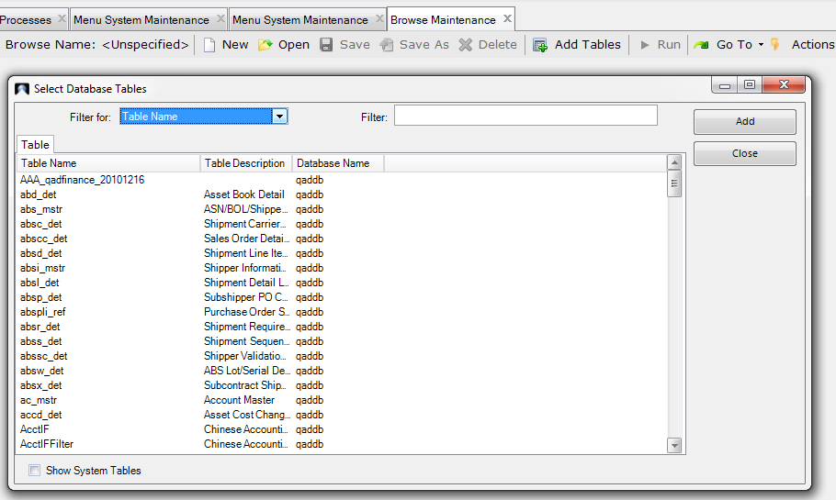

Drag the columns from the up-left tables into the bottom tables.

For instance ,create an inquiry using table pt_mstr

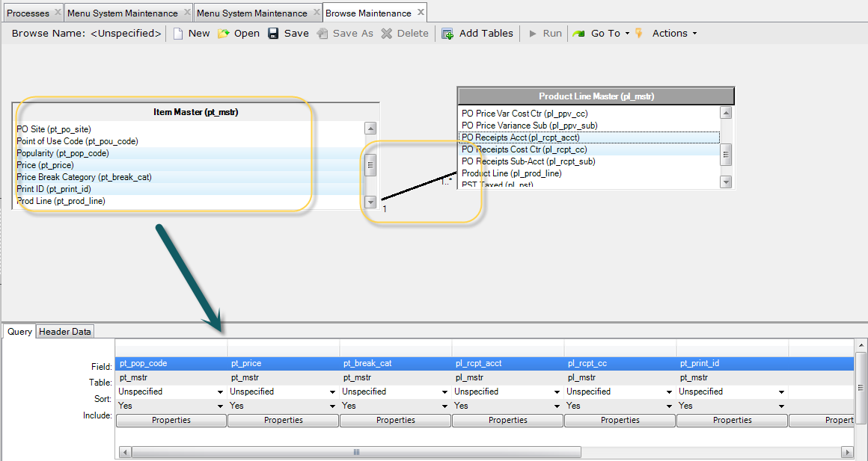

Assign the browser name .Note that the name should be restrict starting with “xx”

And trailing with “numeric(553..)”

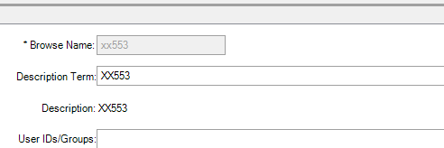

2.lanuch the former browser in menu

Choose available menu “6” and selection

Exec procedure convention is xx+br+555.p

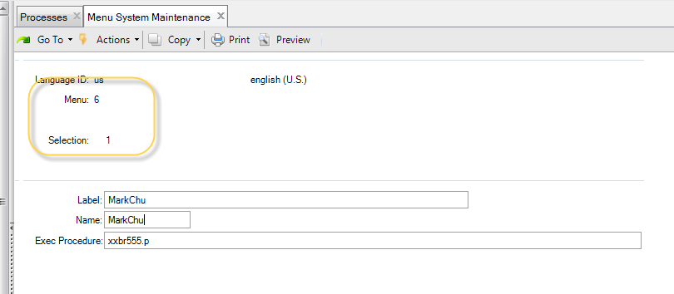

3.grant the menu to role

Firstly check current user group by browsing

“role membership maintenance”(menu36.3.6.6)

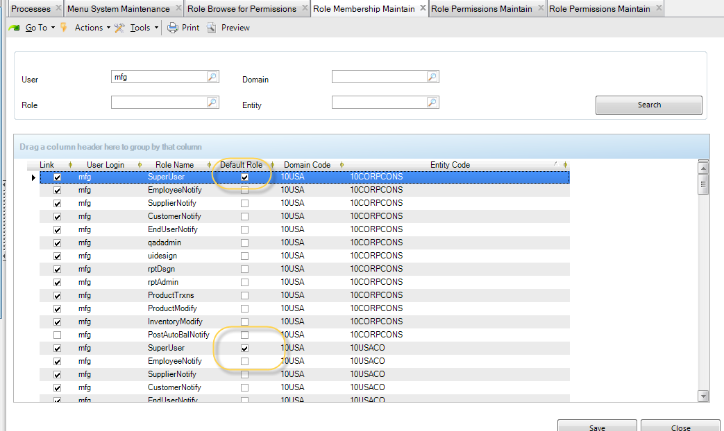

Secondly ,enable menu browsing permission to the user role

Menu “Role Permissions Maintain”36.3.6.5

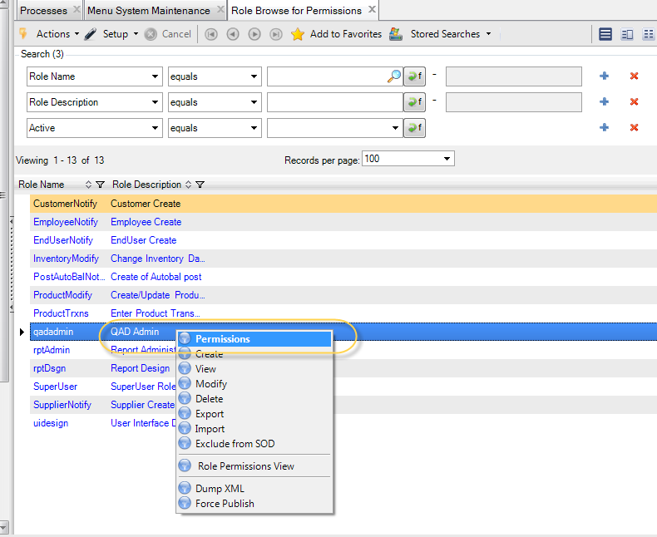

Expand the tree to locate the target menu then hook it to enable permission

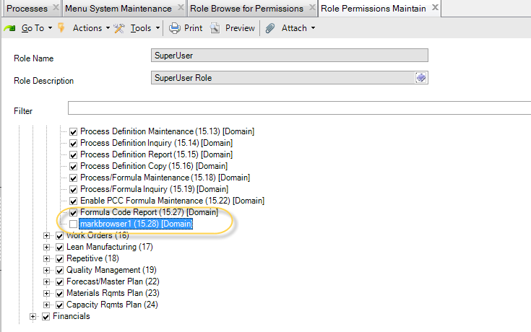

Exit or log off to take effect .

***3.Custom menu page***

Configurable 可配置菜单

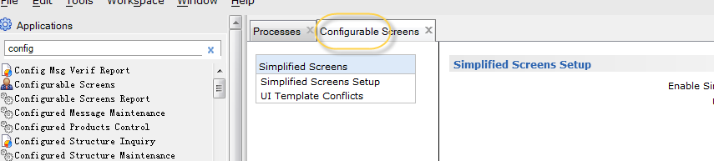

1)36.3.6.6 use role membership maintain

To maintain the group

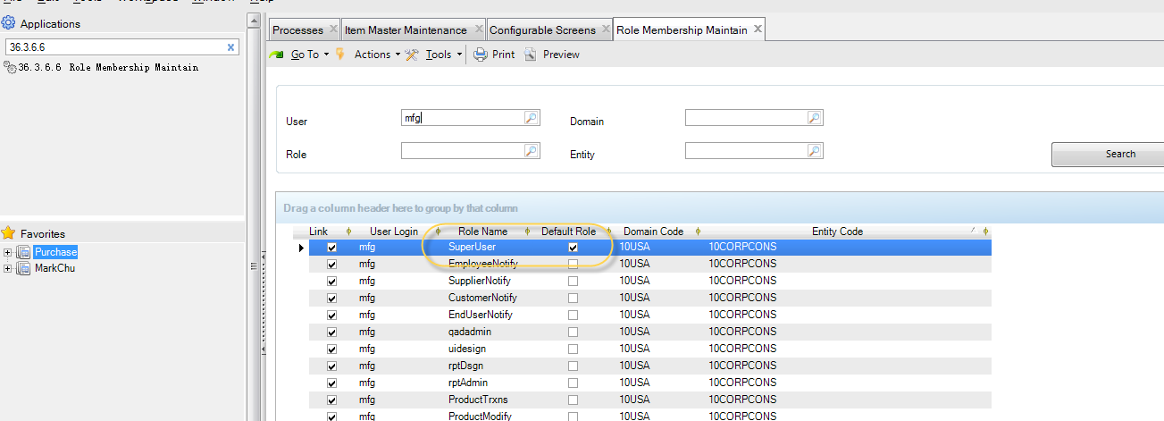

Lanuch menu “configurable” to turn on the design functionality for the group .

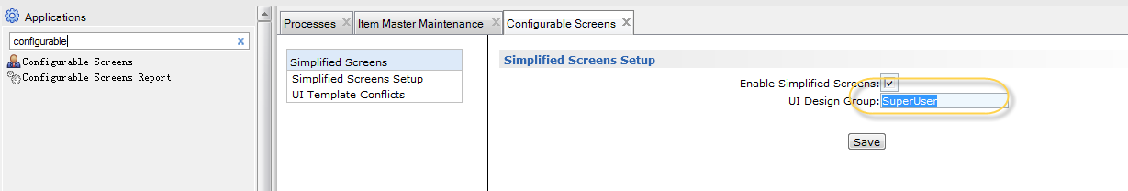

Design the targeted menu. Position on the menu icon and right click to populate the

Pop-up page.

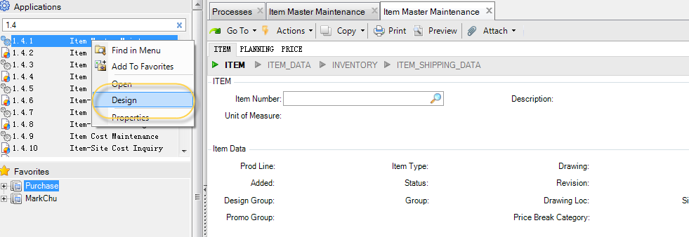

Save template

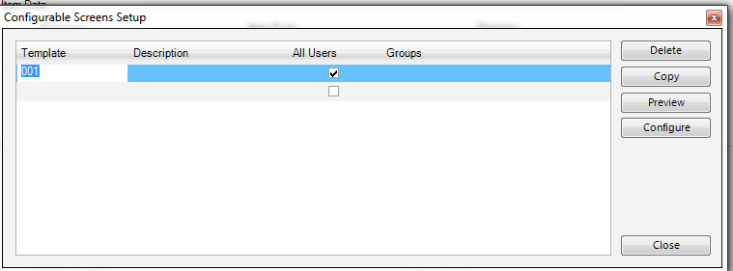

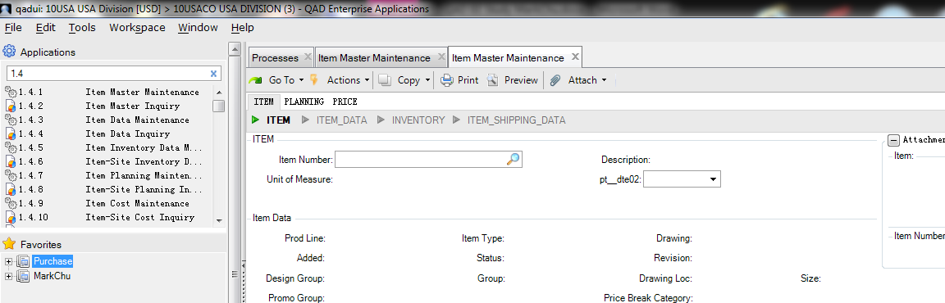

Menu1.6 Item browse 物料浏览

## May29.2013

### Sales

1.Agenda

基础主档(foundation archieve?)

1.物料

1)零件状态 item menu id is 1.4.5 Item maintenance

2)产品线 product line

3)1.4.3

4块数据需要完成，才能维护物料数据

基础数据、库存数据、计划数据、成本数据

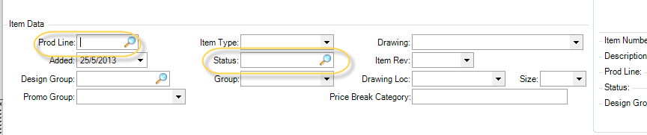

STATUS（1.1.5 物料状态维护）

状态初期不可用，先维护物料状态代码维护

1.4.5 物料数据维护

1.4.16 不同地点(工厂plant)下不同的库存数据

1.4.7 计划数据和MRP有关的数据 planning data related to MRP data

***配置产品 Business***

1.（不同具体类型）就是一个成品编码（BOM组合有一百种）

2. 不能做产品入库

3.不能做预测（BOM不确定）

替代方法：这款车销售的形式，一一对应N种BOM。

1.4.7 物料计划 Item planning

22.1 预测维护 forecast maintenance

Si_mstr concept

废品率

100个零件固定的损耗率5%，采购发料就需要105个

23.2 再生物料计划 regenerate material planning

13.7 物料用途表

子件在所有成品中用到的地方

13.6产品结构查询 product structure inquiry

BOM

<http://en.wikipedia.org/wiki/Bill_of_materials>

A **bill of materials** (sometimes **bill of material** or **BOM**) is a list of the raw materials, sub-assemblies, intermediate assemblies, sub-components, parts and the quantities of each needed to manufacture an [end product](http://en.wikipedia.org/wiki/Product_(business)). No physical dimension is described in a BOM, however the rough outline should include:[[1]](http://en.wikipedia.org/wiki/Bill_of_materials#cite_note-Reid-1)[[2]](http://en.wikipedia.org/wiki/Bill_of_materials#cite_note-Monk-2)

13.9 产品结构复杂product structure copy

Step1. 36.1.4.3.1

2.5.1 推销员

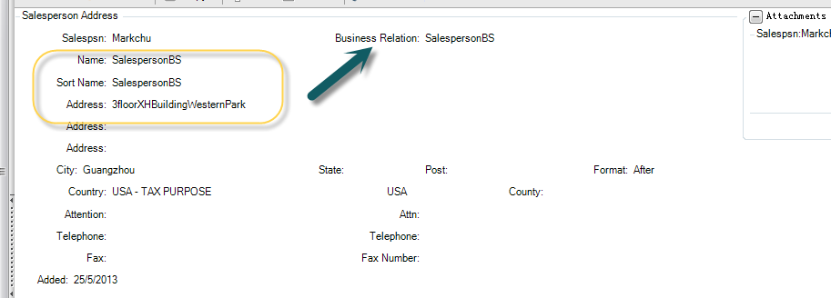

Skip (should be maintain business relationship of customer )

27.20.1.1 firstly maintain customer

Then maintain customer data

2.1.1 menu id

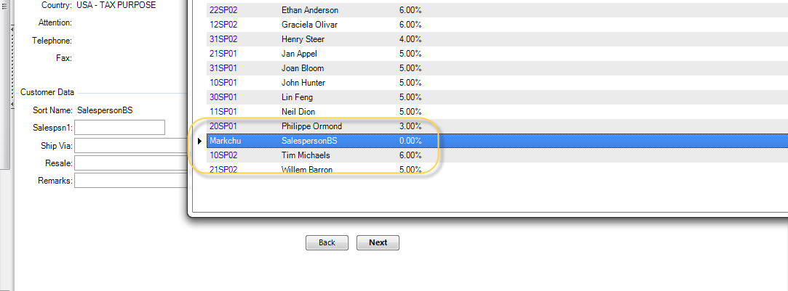

Site 从我们的地点发给客户。

客户地址在上方表格。

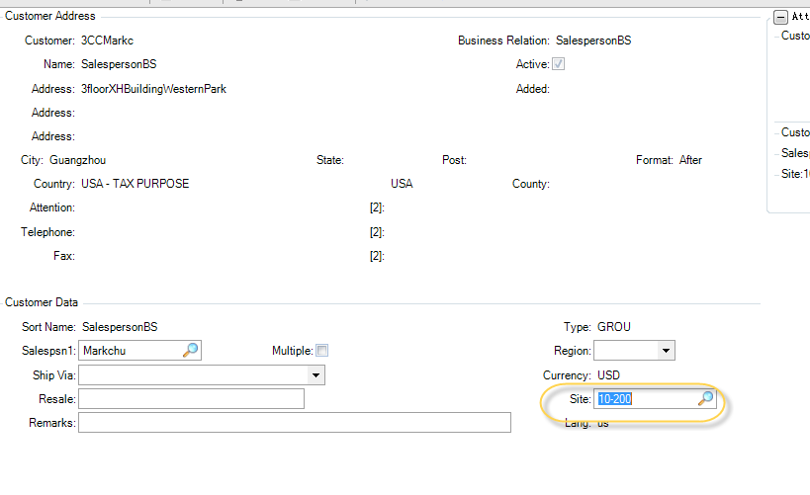

After maintained customer data, can view the result in 2.1.2 menu.

We can add several shipment address of customer

In menu 27.20.2.1

1.10价格单维护(price list)

7.1.24 Sales Order Control

ATP?可承诺量（available to Promise，简称ATP）

QAD**备料有什么影响？**

**查看可备料是否充足**

对装箱单有影响

客户给我们下单（PO）

我们将订单输入到系统就是SO

EMT（enterprise material transfer）企业物料转移。贸易型公司那个。

一个会计单位

不同DOMAIN的财务、结算都是不同的。

The internal trading between Hongkong Domain / mainland domain

Use ***EDI***domain1 po transform to domain2 so

(accessories refer to iphone photo )

***Job after training***

02 工程技术 PPT Page4 Target

01 销售基础数据维护

02 销售预测

03 销售订单

PPT PAGE3 Target (Main menu)

### Operation

工艺流程

1.什么是排产？

## MRP

1.什么是倒排程？

2.什么是产能？（制作提前期）

3.MRP 虚拟件

指标 identifier: 库存inventory(x)、成本cost、计划planning(不下工单no order)

用途function:

1. 用尽原则

刚开始，K是旧件，有库存的。

1. 包装料

将相关LEVEL、LABEL类似物料的打包成一个包装料（作为K虚拟机）

1. 正式

例如电脑（实际存在的成品）实际发送的物料是鼠标、键盘。

将电脑作为K，包含鼠标、键盘等物料

全局global 1.4.1

局部particular

虚拟件VIRTUAL ITEM

1.1.1 库存状态代码维护

买sold 用丢

ITEM IQC RW SCRP

可用

可计划

什么是成品？什么是批件？

LFL(Lot-to-Lot)分批订货方法

FOQ(fixed order quantity)固定订单数据的Order Policy

一般用POQ

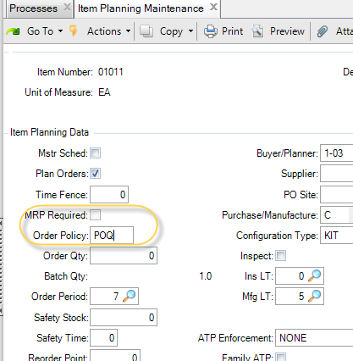

什么是安全库存？理想状况下安全库存是不用的。但为防止意外的情况。

1、原材料的平均用料

2、供应商送货的平均周期

***订货点不应用于MRP计算的物料（一定比安全库存高）***

什么是M件（manufacture）？P(Purchase)件？

M件在MRP会穿透到下一层。P不会穿透。

什么是请购单？

## How to startup QAD back-end services

CD /app/mfgpro/eb21sp6

Cd ./client.Demonstration

## How to compile QAD .P program

1. Upload .P files to QAD Server(usual is Linux/Unix)

We can use the FTP tool to upload

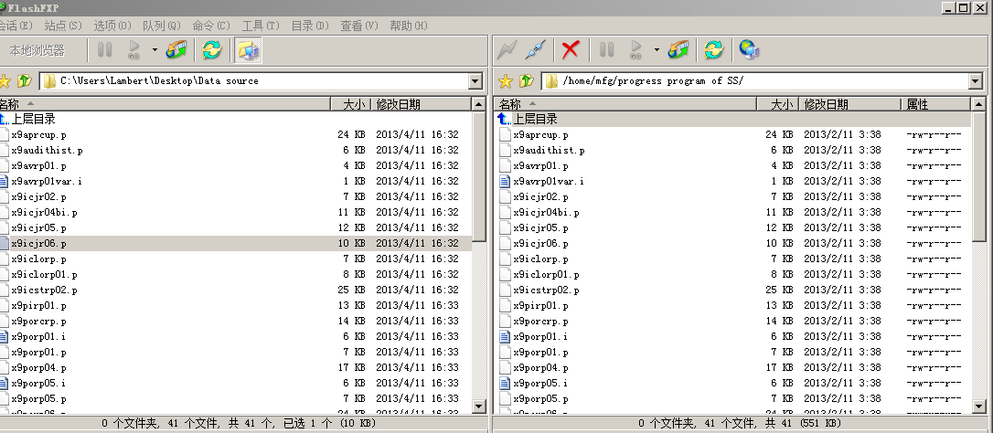

Alternatively use FTP command to upload

C:\Users\Lambert>ftp 192.168.28.77

ftp> bye

C:\Users\Lambert>ftp 192.168.228.77

连接到 192.168.228.77。

220 (vsFTPd 2.0.1)

用户(192.168.228.77:(none)): mfg

331 Please specify the password.

密码:

230 Login successful.

ftp>lcd c:\test

目前的本地目录 C:\TEST。

ftp> put ssbipo01.p

200 PORT command successful. Consider using PASV.

150 Ok to send data.

226 File receive OK.

ftp: 发送 13422 字节，用时 0.00秒 4474.00千字节/秒。

ftp>mput *.p

mput ssbipo01.p? y

200 PORT command successful. Consider using PASV.

150 Ok to send data.

226 File receive OK.

ftp: 发送 13422 字节，用时 0.00秒 6711.00千字节/秒。

ftp>mput *.i

mput a6mfdtitle.i? y

200 PORT command successful. Consider using PASV.

150 Ok to send data.

226 File receive OK.

ftp: 发送 4288 字节，用时 0.00秒 4288.00千字节/秒。

mput a6mfrtrail.i? y

200 PORT command successful. Consider using PASV.

150 Ok to send data.

226 File receive OK.

ftp: 发送 7030 字节，用时 0.00秒 3515.00千字节/秒。

mput a6poporp0601.i? y

200 PORT command successful. Consider using PASV.

150 Ok to send data.

226 File receive OK.

ftp: 发送 4276 字节，用时 0.00秒 4276.00千字节/秒。

ftp> y

无效命令。

ftp>

Tip: Note that we should upload every relative resource files completely.

1. Compile .p files
2. use SS customized utility

Log in QAD and go to the blank below ,and input this command “xxcom”

Source Directory : the uploaded folder

Prefixed with **xx** always be the customization file

.p is progress program file.

.i is reference file for .p .



Compile Propath:

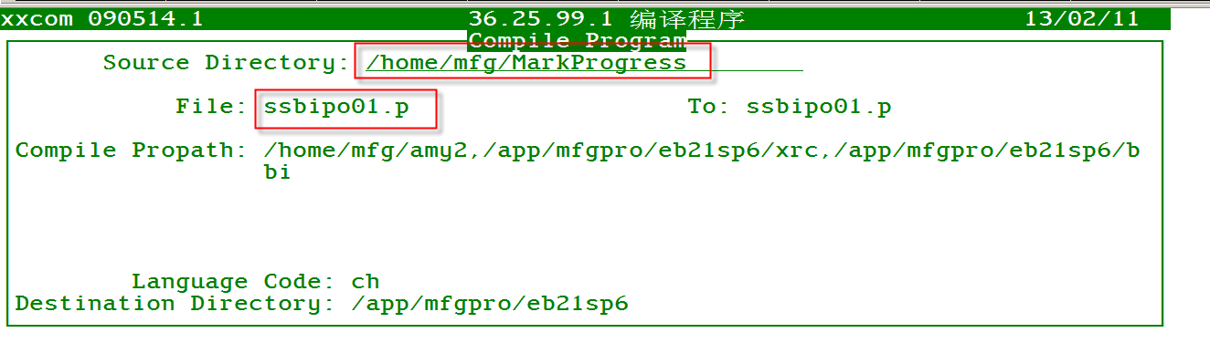

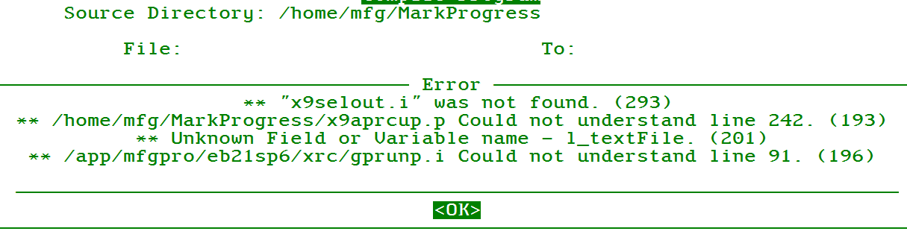

1. Log in QAD and go to the menu to run the program

Others

1. **Shortcut Key**
2. Ctrl + z reset and clean all text



1. Convention rule

xxicjr02.p is progress program name./xxicjr02.frp is corresponding BI report template.

1. How to set the customized output option

Choose output option as “Page” , the text file outputted by progress program will display on the screen directly.

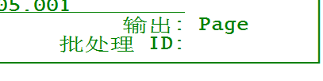

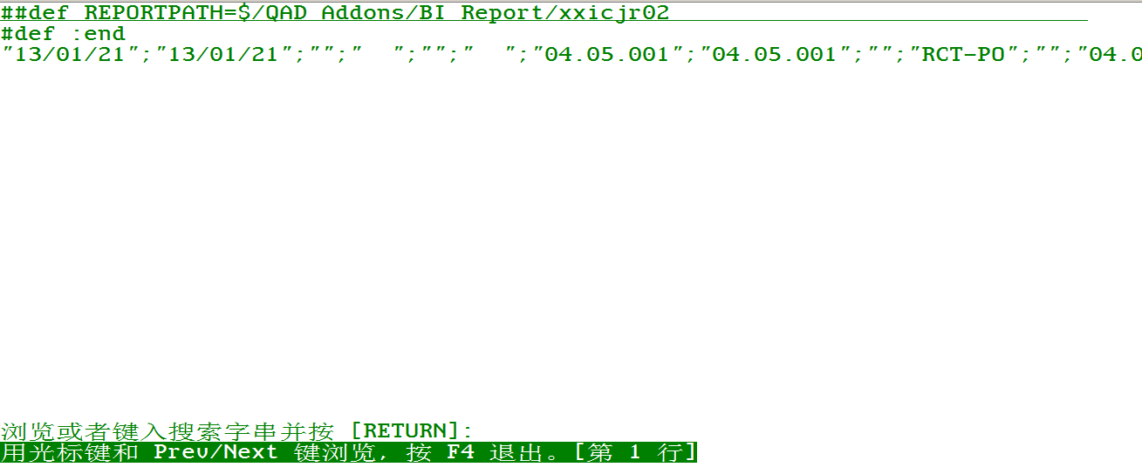

A) customize the printer option use the BIReport.exe

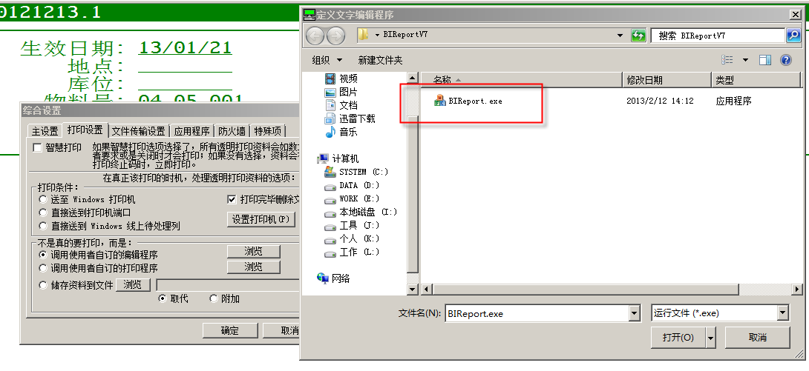

B) How to set the QAD Print option

# SAM Internal Trainning

## June 17, 2013

seq40:

1、付款的结构

Electronics :先到电子，然后到实际科目

Debit : …

2、定义AP/AR 收款的流程

seq41:

42 Account Create

Asset combox :

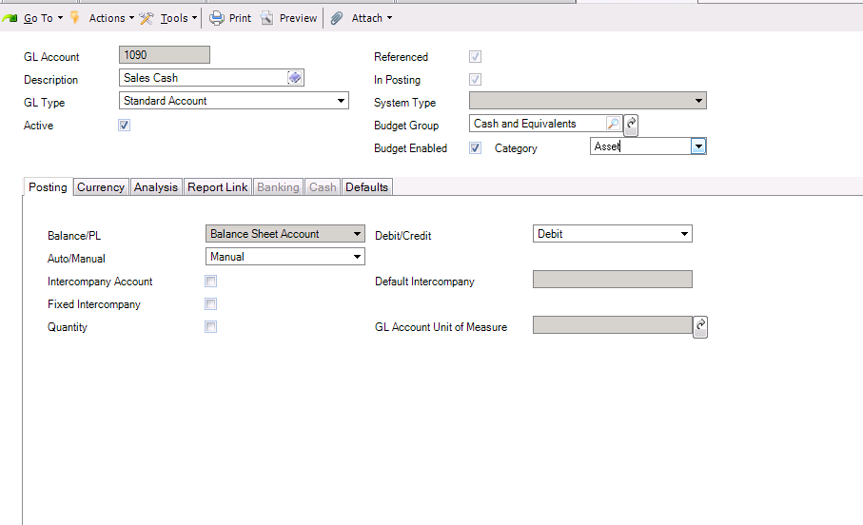

Intercompany:公司间交易

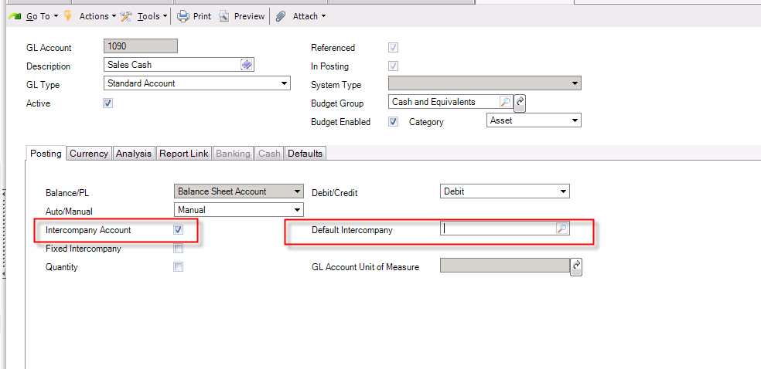

总帐数量

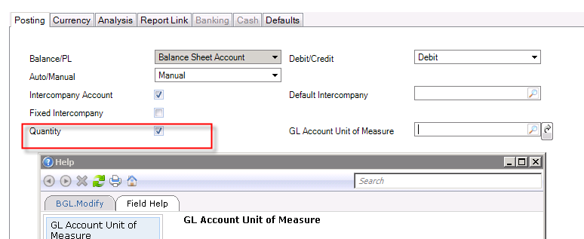

CURRENCY:

1. 每个科目可以不指定currency.

Left two option blank.

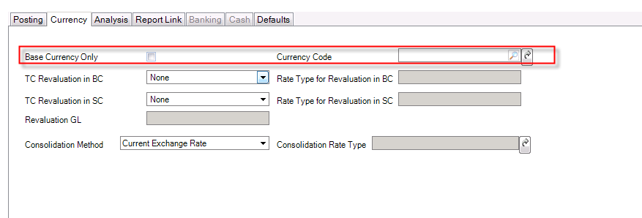

第一个打勾？

双本未币：所有的交易都要做EXCHANGE.

先导入RevaluationGL后导入TC Revaluation in BC

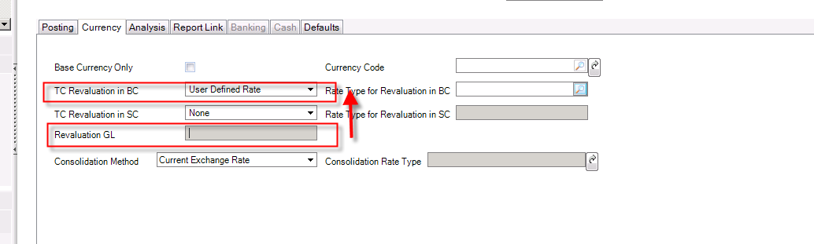

位：

银行存款的下一级

Sub-Account:打钩一定要用。

需要先定义子科目（一个子科目可以用到多个GL上）

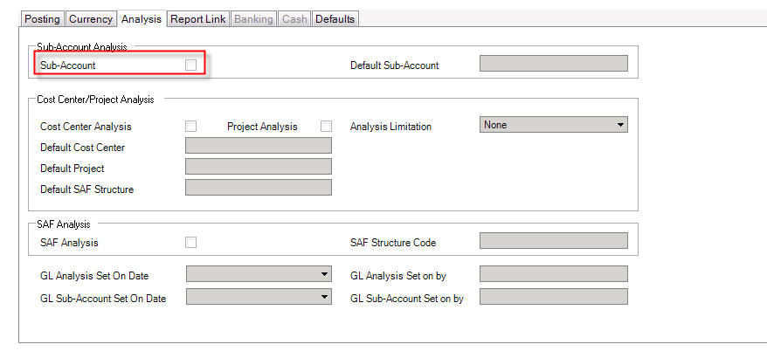

导入科目（25.3.13.1）

1. 先用25.3.13.3查看GL

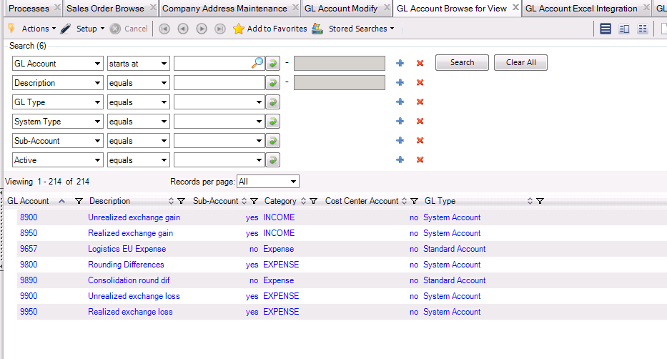

1. 用25.3.13.5导入文件

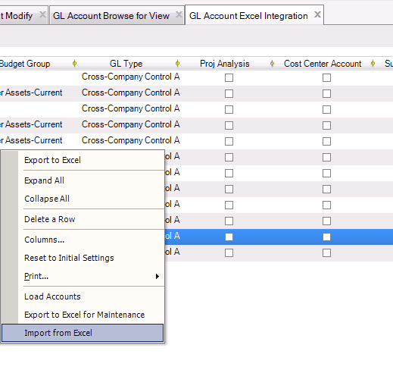  
clear USD.

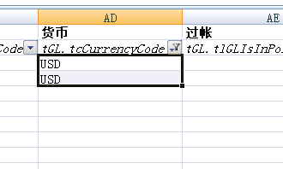

Attention: sub-account is not established yet , so that the sub-account related-value should be removed.

Import seq3 : sub-account should be disabled.

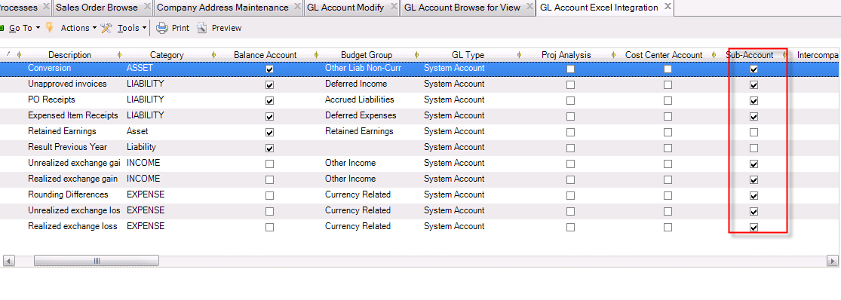

Text of sub-account column should be clear.

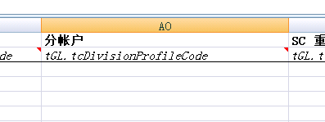

The below flag column value should be assigned to false.

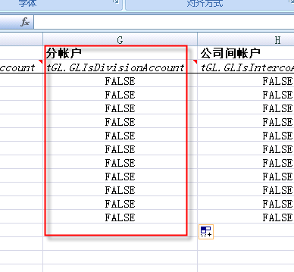

1. Account Type

1)cross-company 公司间

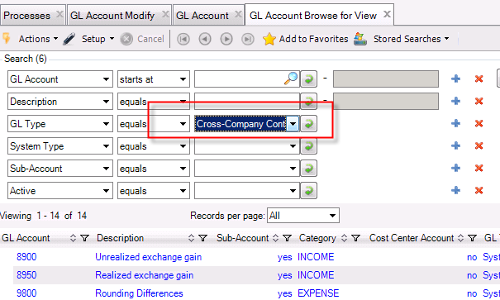

System

Conversion 4 舍5入

Unapproved Invoice 未批核的发票

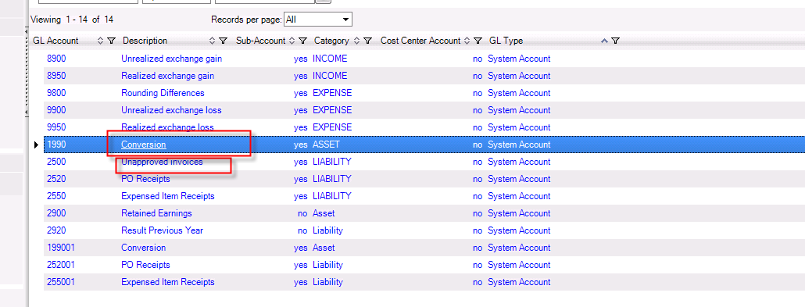

暂估帐目

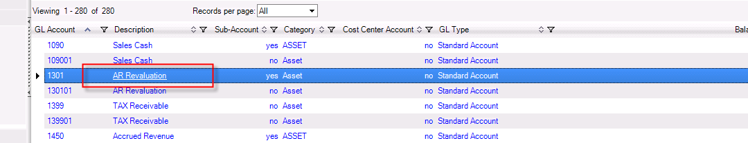

固定资产Fixed Assets

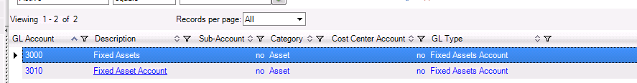

银行帐目：

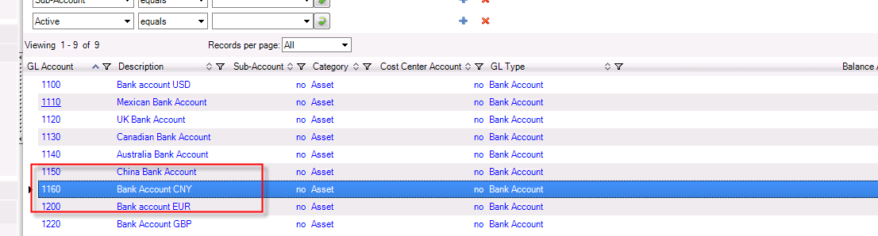

Open the account to check the details:

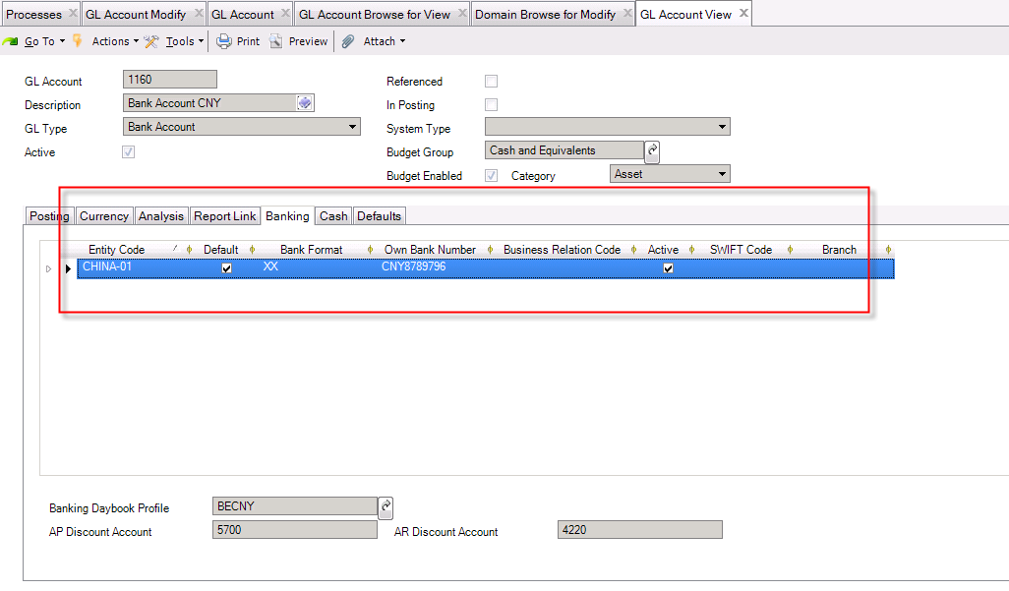

银行构建新增BR

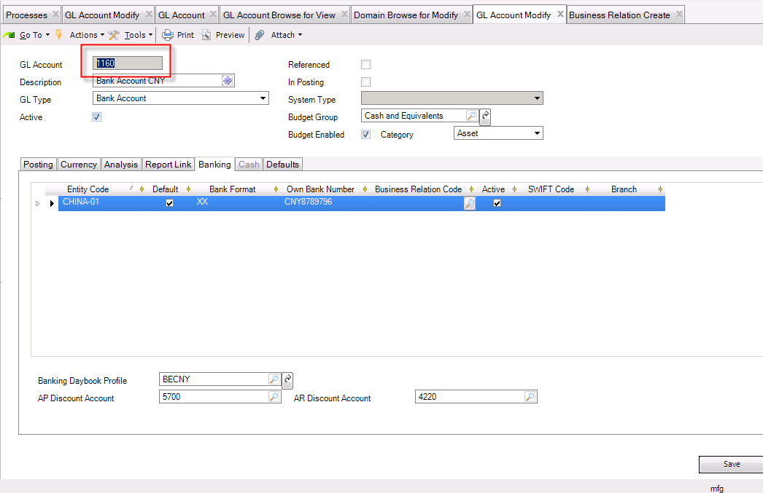

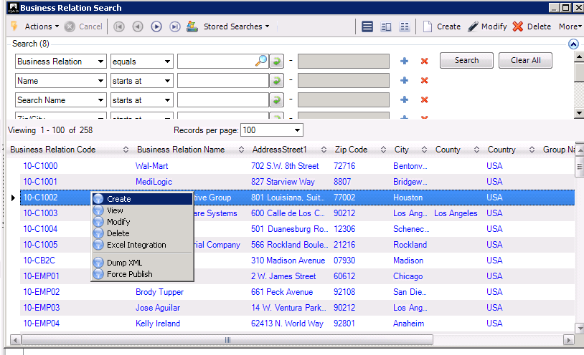

写银行的地址：

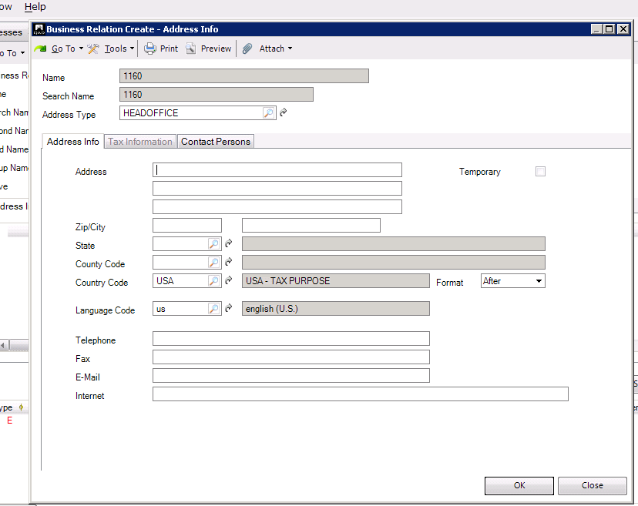

Cost center

Project Group Modify

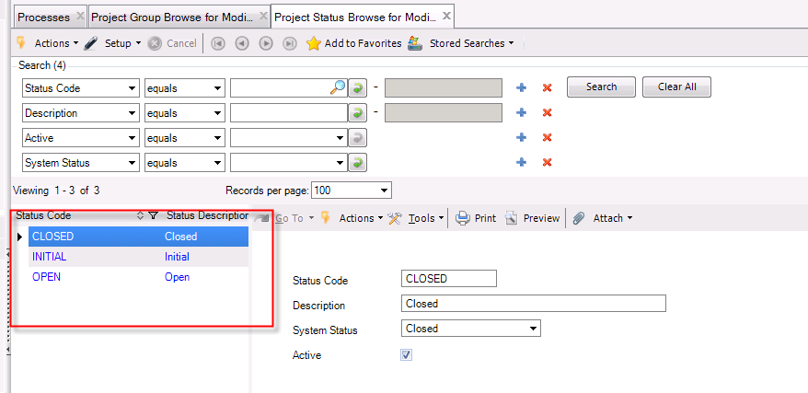

49 Account control 36.9.24

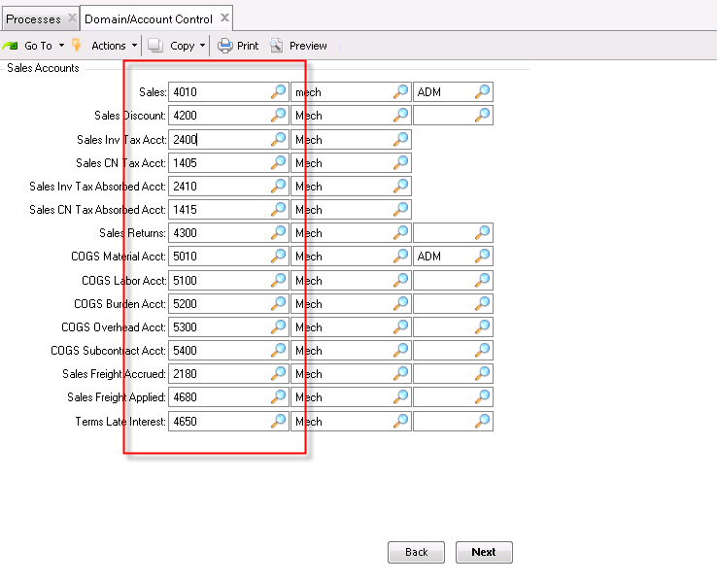

The actual account is as below:

mgglpm.p 3+               36.9.24

Domain/Account Control              03/01/13  
谀哪哪哪哪哪哪哪哪哪哪哪哪哪哪哪 Sales Accounts 哪哪哪哪哪哪哪哪哪哪哪哪哪哪哪目  
?                       Sales: 4000101                                        ?  
?              Sales Discount: 4200101   Elec                                 ?  
?          Sales Inv Tax Acct: 240001    elec                                 ?  
?           Sales CN Tax Acct: 140501    ELEC                                 ?  
? Sales Inv Tax Absorbed Acct: 241001    elec                                 ?  
?  Sales CN Tax Absorbed Acct: 141501    ELEC                                 ?  
?               Sales Returns: 4300101   ELEC                                 ?  
?          COGS Material Acct: 5000101   ELEC                                 ?  
?             COGS Labor Acct: 5100101   ELEC                                 ?  
?            COGS Burden Acct: 5200101   ELEC                                 ?  
?          COGS Overhead Acct: 5300101   ELEC                                 ?  
?       COGS Subcontract Acct: 5400101   ELEC                                 ?  
?       Sales Freight Accrued: 2180101   ELEC                                 ?  
?       Sales Freight Applied: 4680101   ELEC                                 ?  
?         Terms Late Interest: 4650101   ELEC                                 ?  
滥哪哪哪哪哪哪哪哪哪哪哪哪哪哪哪哪哪哪哪哪哪哪哪哪哪哪哪哪哪哪哪哪哪哪哪哪哪哪馁  
  
  
mgglpm.p 3+               36.9.24 Domain/Account Control              03/01/13  
谀哪哪哪哪哪哪哪哪哪哪哪哪哪哪?Accounts Payable 哪哪哪哪哪哪哪哪哪哪哪哪哪哪哪?  
?             AP Inv Tax Acct: 140001    ELEC                                 ?  
?              AP CN Tax Acct: 240501    ELEC                                 ?  
?    AP Inv Tax Retained Acct: 142001    ELEC                                 ?  
?     AP CN Tax Retained Acct: 241501    ELEC                                 ?  
?      Expensed Item Receipts: 255001    ELEC                                 ?  
?     Expensed Item Usage Var: 5650101   ELEC                                 ?  
?      Expensed Item Rate Var: 5660101   ELEC                                 ?  
滥哪哪哪哪哪哪哪哪哪哪哪哪哪哪哪哪哪哪哪哪哪哪哪哪哪哪哪哪哪哪哪哪哪哪哪哪哪哪馁  
  
Sam(635283768)  4:14:40 PM  
谀哪哪哪哪哪哪哪哪哪哪哪哪哪哪哪哪 Department 哪哪哪哪哪哪哪哪哪哪哪哪哪哪哪哪目  
?          Cost of Production: 5770101   ELEC                                 ?  
?                       Labor: 5120101   ELEC                                 ?  
?                      Burden: 5220101   ELEC                                 ?  
滥哪哪哪哪哪哪哪哪哪哪哪哪哪哪哪哪哪哪哪哪哪哪哪哪哪哪哪哪哪哪哪哪哪哪哪哪哪哪馁

*Problem1: What’s Daemon???*